

**ADVANCED DATABASES**

**NAME: ROHIT PASKARAN**

**STUDENT ID: @00649876**

**Contents**

**Chapter 1: Task 1 -** Measure the Child Poverty of Four Countries

* Abstract.
* Introduction
* 3. Relational Schema.
* 4. Design Rationale and table creation.
* 5. Database Normalization.
* 6. Transaction and Concurrency.
* 7.Error handling.
* 8. TSQL Statements.
* 9. Database Security.
* 10.DataBase Backup and Strategy.
* 11. Data Privacy and Ethical Issues.
* 12. Conclusion.

**Chapter 2: Task 2 -** measure the inequality in the education sector in Vietnam.

* Abstract.
* Introduction
* Table creation.
* Database Normalization.
* Transaction and Concurrency.
* Error handling.
* TSQL Statements.
* Report Design
* Database Security.
* DataBase Backup and Strategy.
* Data Privacy and Ethical Issues.
* Conclusion.

**Chapter 3: Task 3 -** Measure the Child Poverty of Four Countries

* Abstract.
* Introduction
* Table creation.
* Database Normalization.
* Transaction and Concurrency.
* Error handling.
* TSQL Statements.
* Report Design.
* Database Security.
* DataBase Backup and Strategy.
* Data Privacy and Ethical Issues.
* Conclusion.

**TASK 1**

1. **Abstract:**

The first Task is to measure the Child Poverty in four Lowincome countries which includes India, Peru, Vietnam and Ethiopia. The Data’s were collected in these on different years. It was collected by rounds of 5, which contains a lot of Information which includes Child Health Conditions, Family Situations and much more. The children’s were at different ages on each individual rounds. Some Children’ were not live at particular years. The datasets were downloaded from the **“young lives”** project. Since 2001, Young Lives has been monitoring the lives of 12,000 youngsters in a unique longitudinal study of poverty and inequality.

1. **Introduction:**
2. **Tool and Programming Languages:**
3. Microsoft SQL Server Management Studio was used for configuring and Managing the Data.
4. TSQL Was used for writing Queries.
5. **Data Source:**
6. **Official website of young lives**

<https://www.younglives.org.uk/>

1. **Downloaded the Data from Here.**

<https://beta.ukdataservice.ac.uk/datacatalogue/series/series?id=2000060#!/access>

Created an Account in the Young lives site with the School Account and downloaded the Datasets.

1. **Data Uploading:**

The Data was Downloaded in the format of zip file which has a lot of folders and contains a technical Document that explains the Meta Data and more information about the data. The Data was in .SAV format when downloaded later Changed it into excel file with the help of Microsoft Excel and then Uploaded to the SQL server management Studio via SQL server Import and Export Wizard. Which is Done after created a Database. There are four files uploaded to the database.

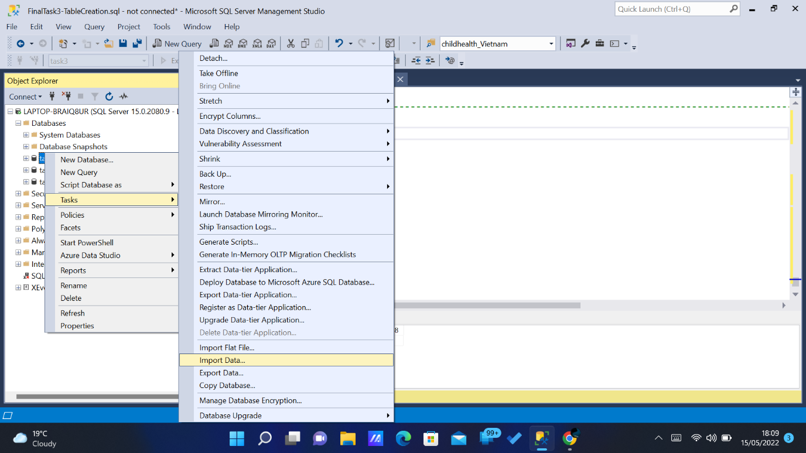

*Fig 2.3.1*

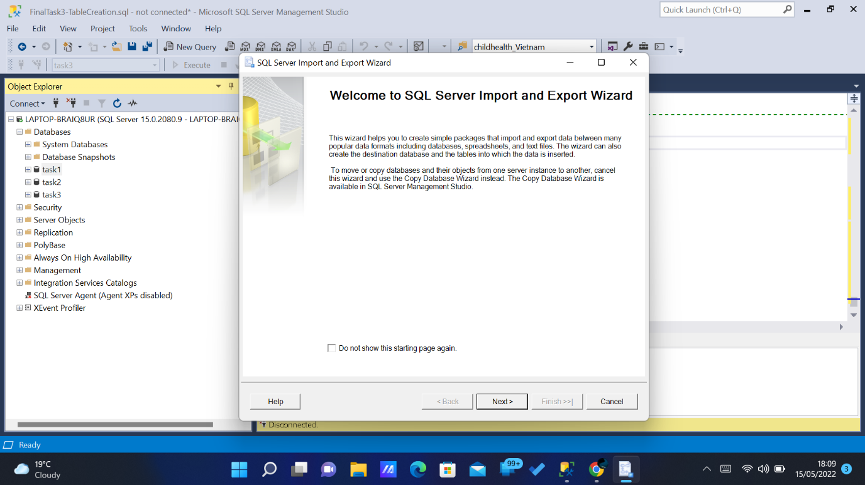

*Fig 2.3.2*

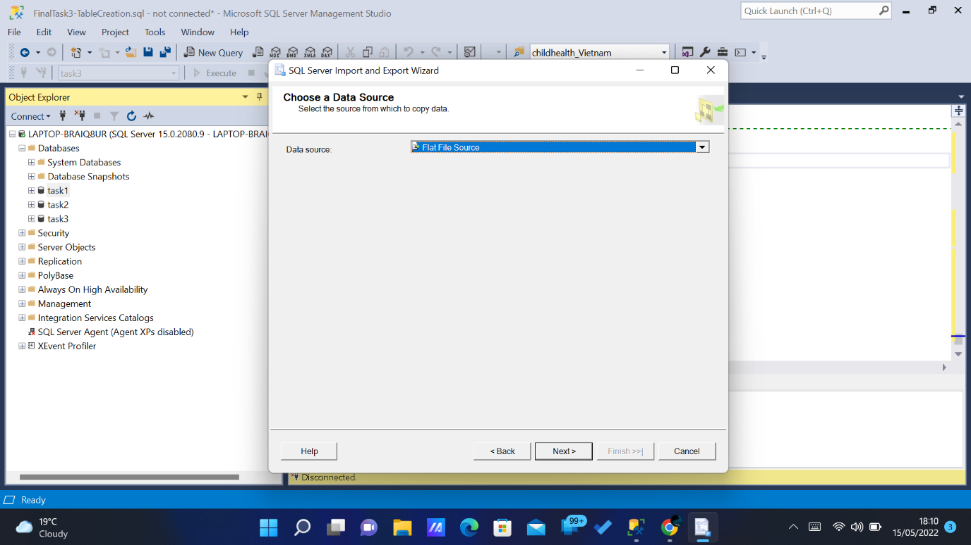

*Fig 2.3.3*

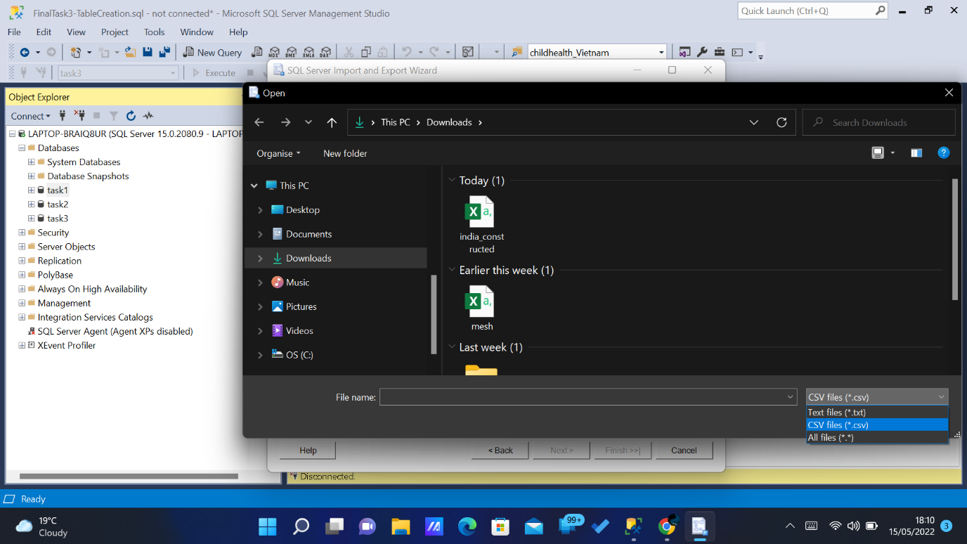

*Fig 2.3.4*

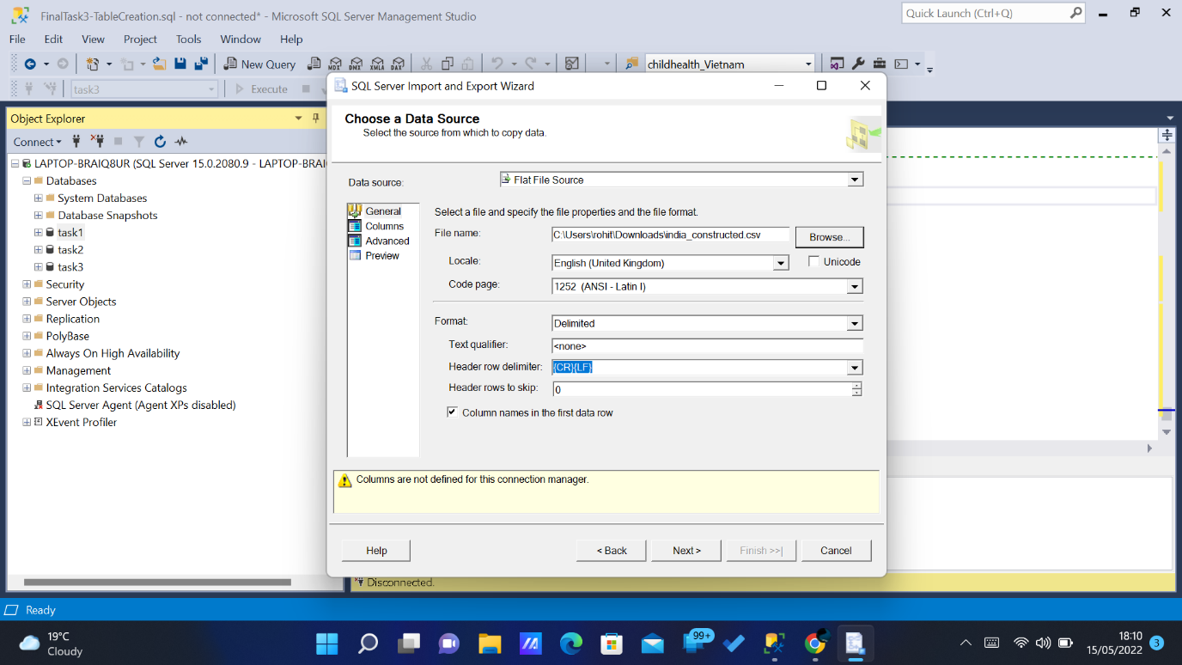

*Fig 2.3.5*

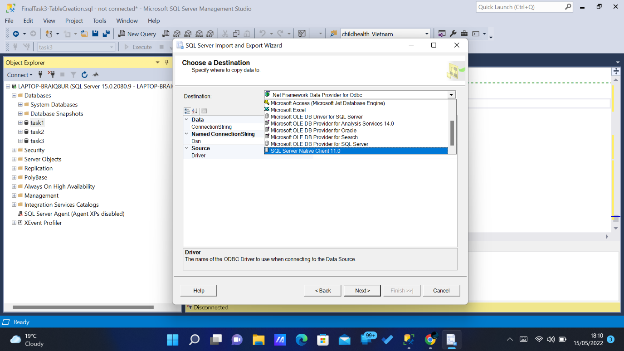

*Fig 2.3.6*

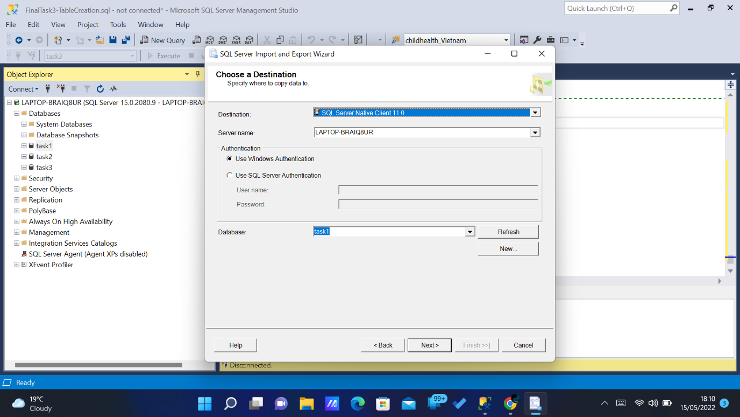

*Fig 2.3.7*

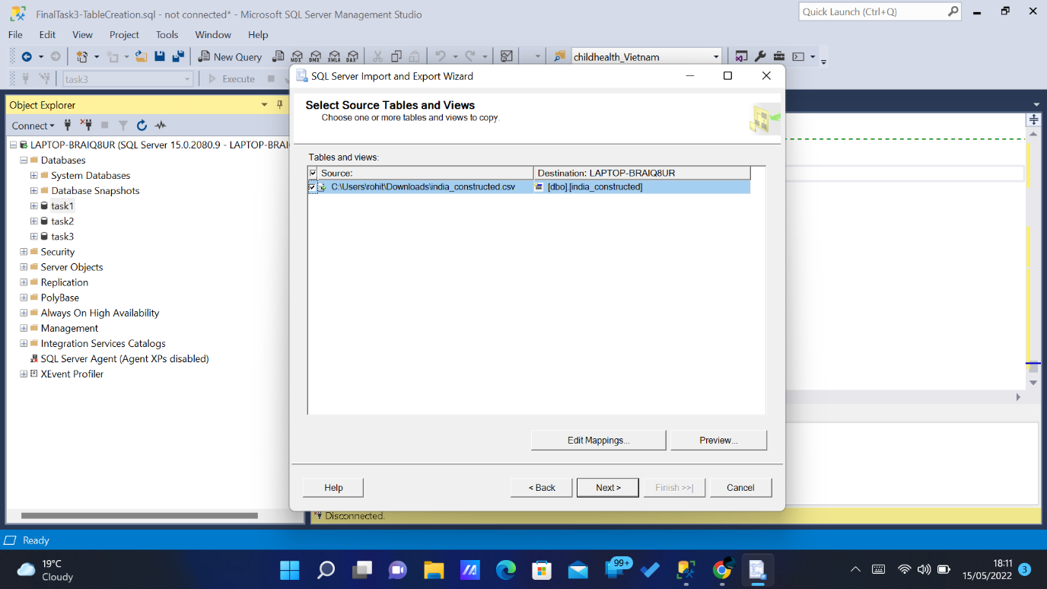

*Fig 2.3.8*

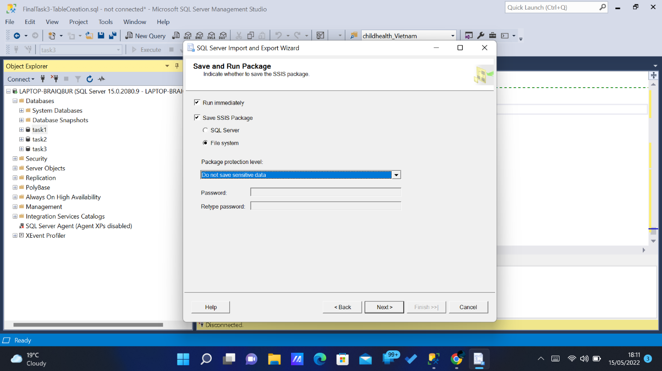

*Fig 2.3.9*

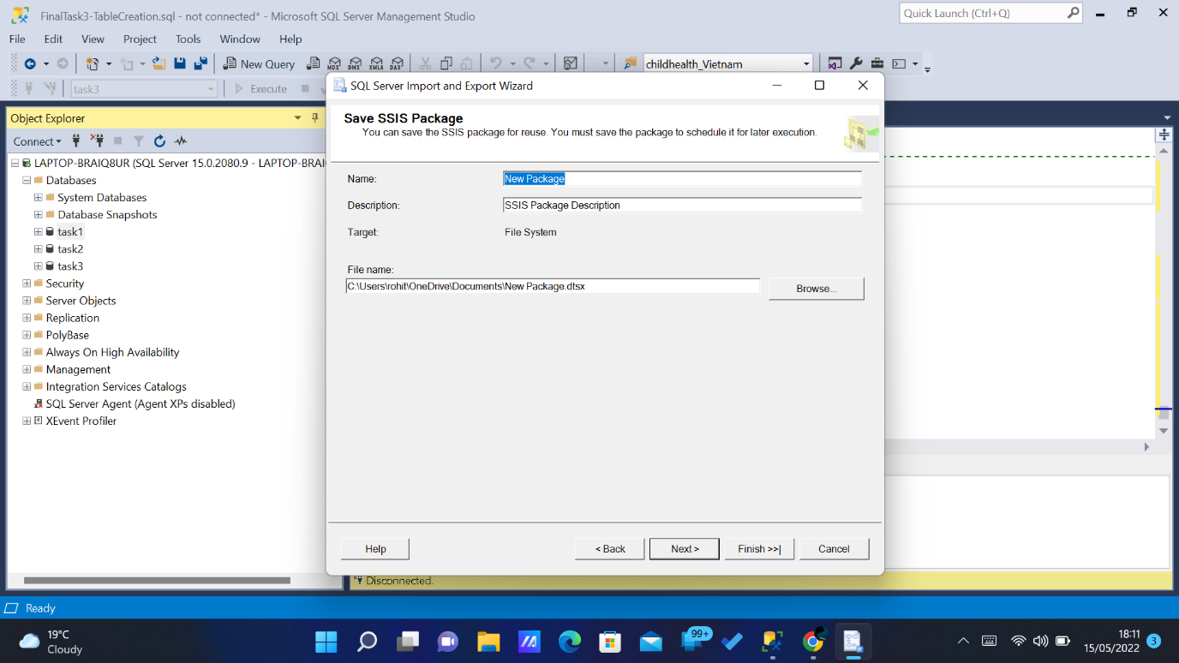 *Fig 2.3.10*

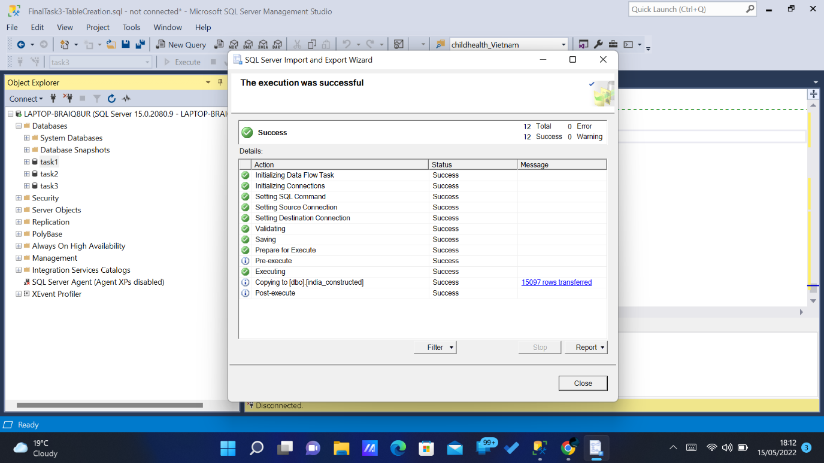

*Fig 2.3.11*

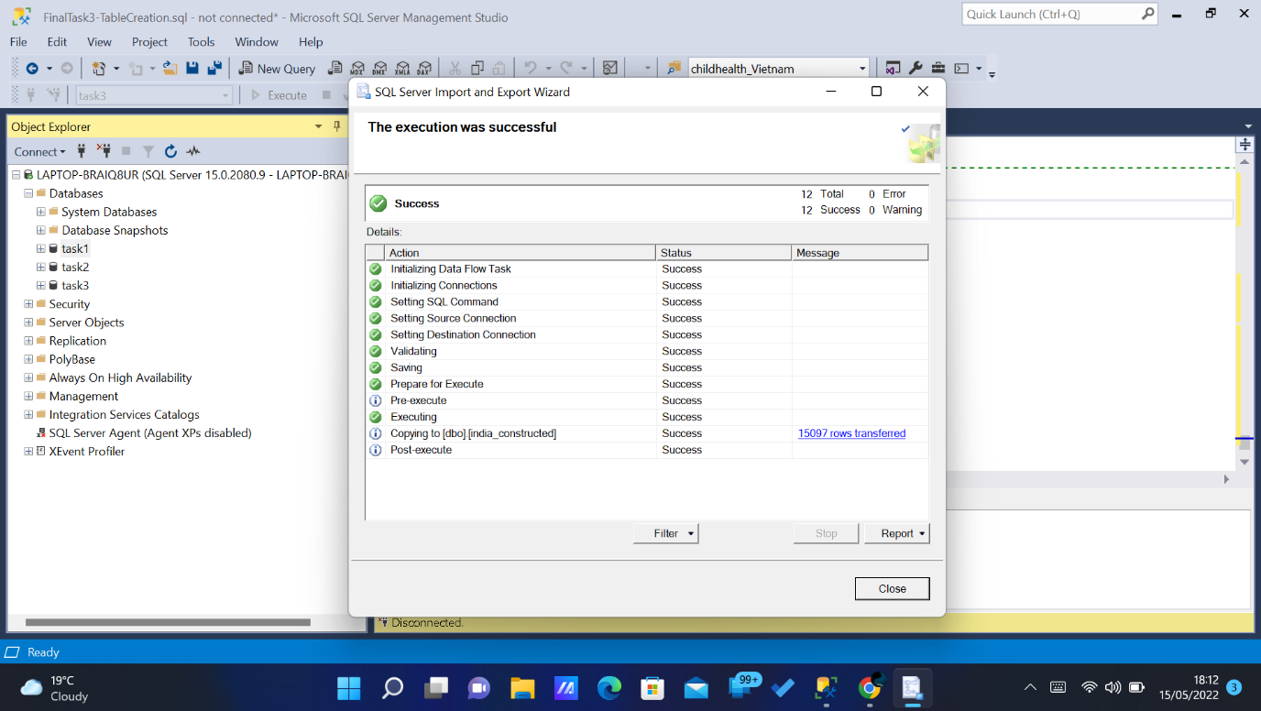

*Fig 2.3.12*

1. **Relational Schema:**

The tables were created with the help of the Main data. The tables were created separately for all four countries.

1. Child-Biography.
2. Child-Health.
3. Economic-Status.
4. Tragedy.

So totally 16 tables where created. The below schema Diagram represents the relationship more clearly.

**Schema Sketch:**

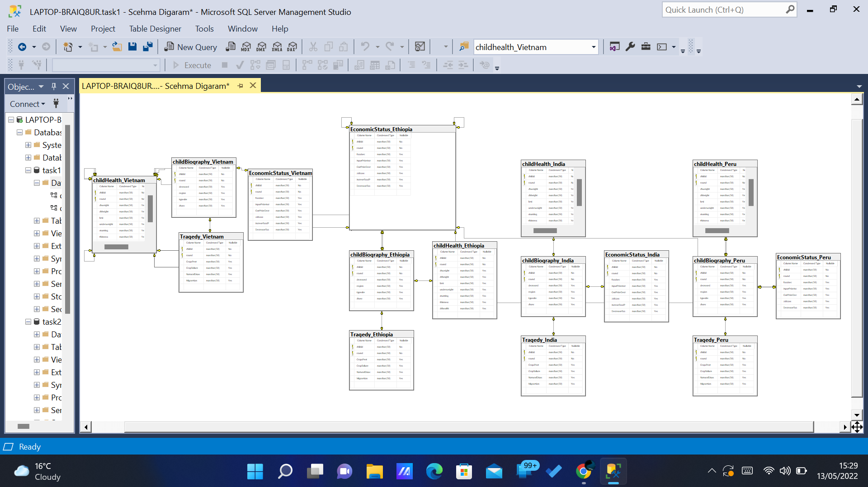

*Fig.3.1.*

*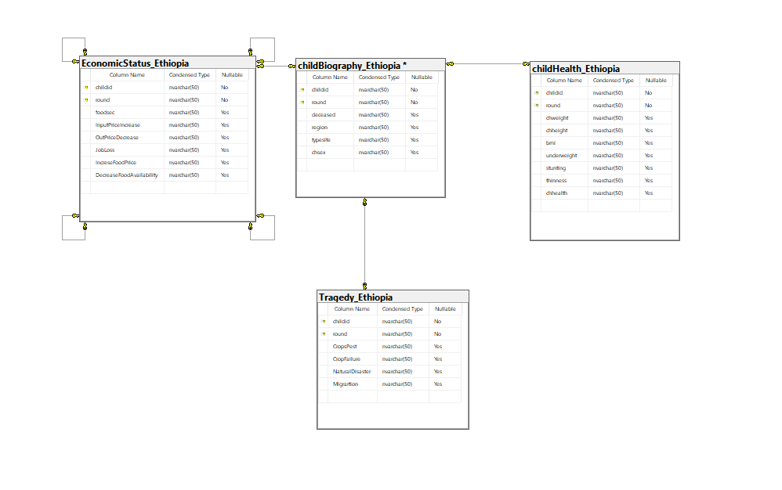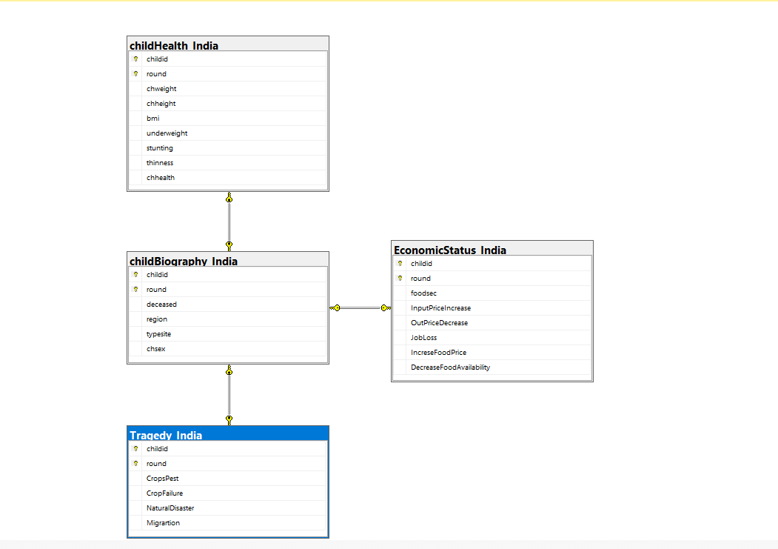 Fig.3.2.*

*Fig.3.3.*

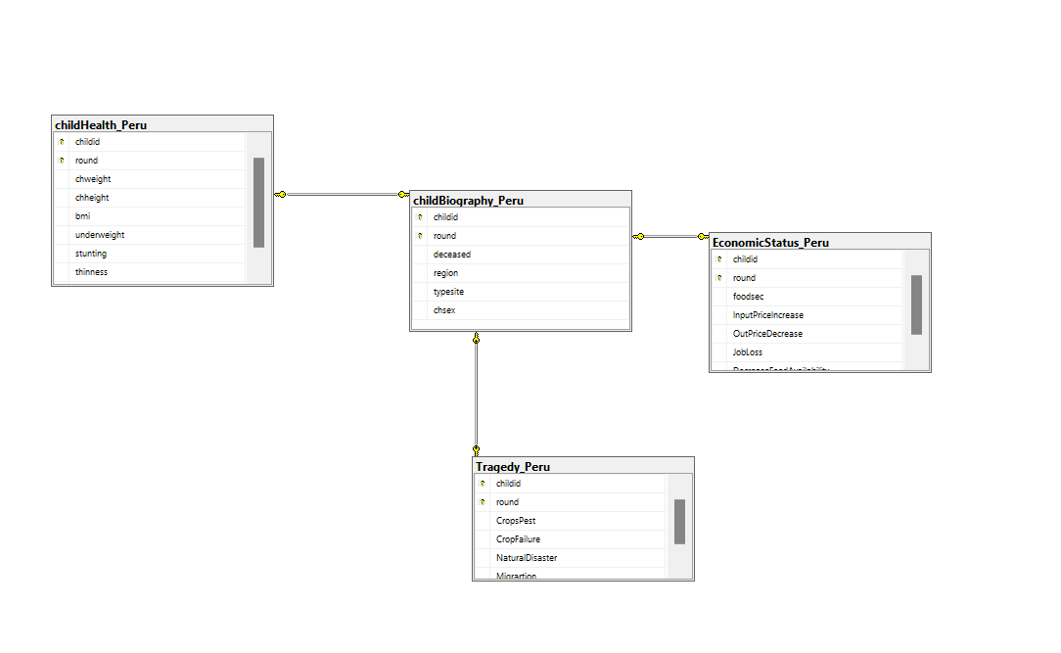

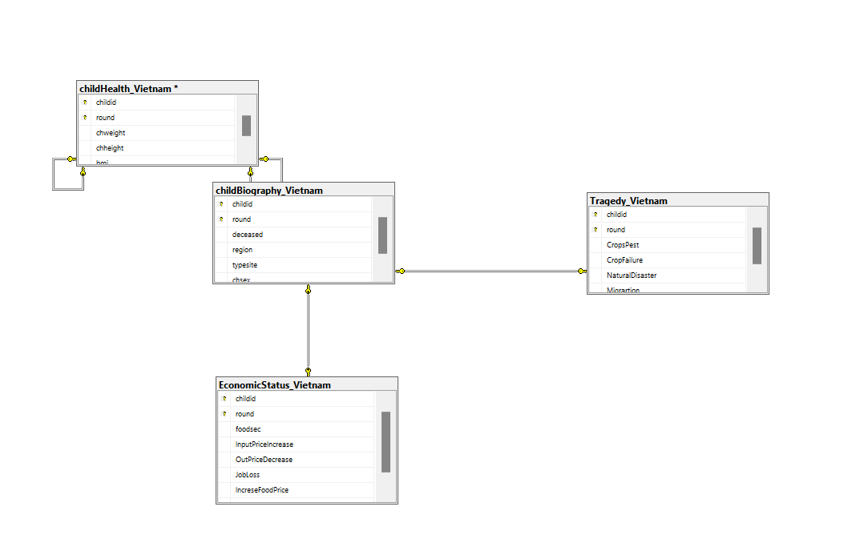 *Fig.3.4.*

*Fig.3.5.*

1. **Design** **Considerations** **and Table Creation.**

Primary key was set to these tables. Child-ID and the Round was taken as a primary key. Due to the repeated values both were taken as a primary key. **“**Child Biography” was Considered has the main Table and all the other tables were connected with that table. So Foreign key was set with the reference of that table.

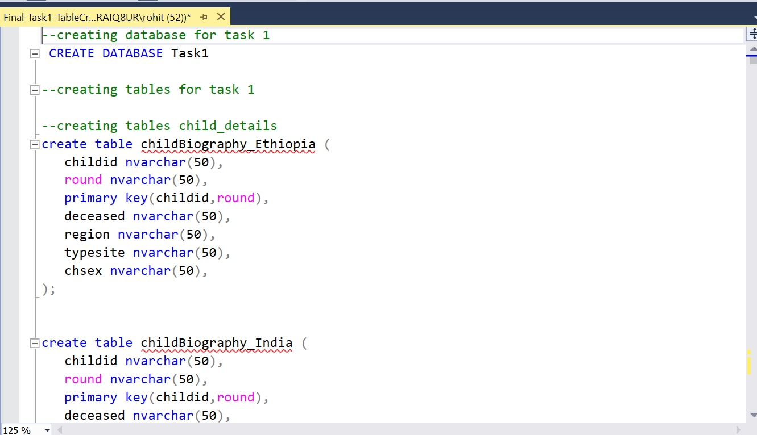The values were inserted to the tables with the help of (Insert Into) Command. **Using the Meta Data Given the values were type-casted while Inserting**. **Case statement was used.** This gives more readability for the Front-End Developer and the users.

*Fig.4.1.*

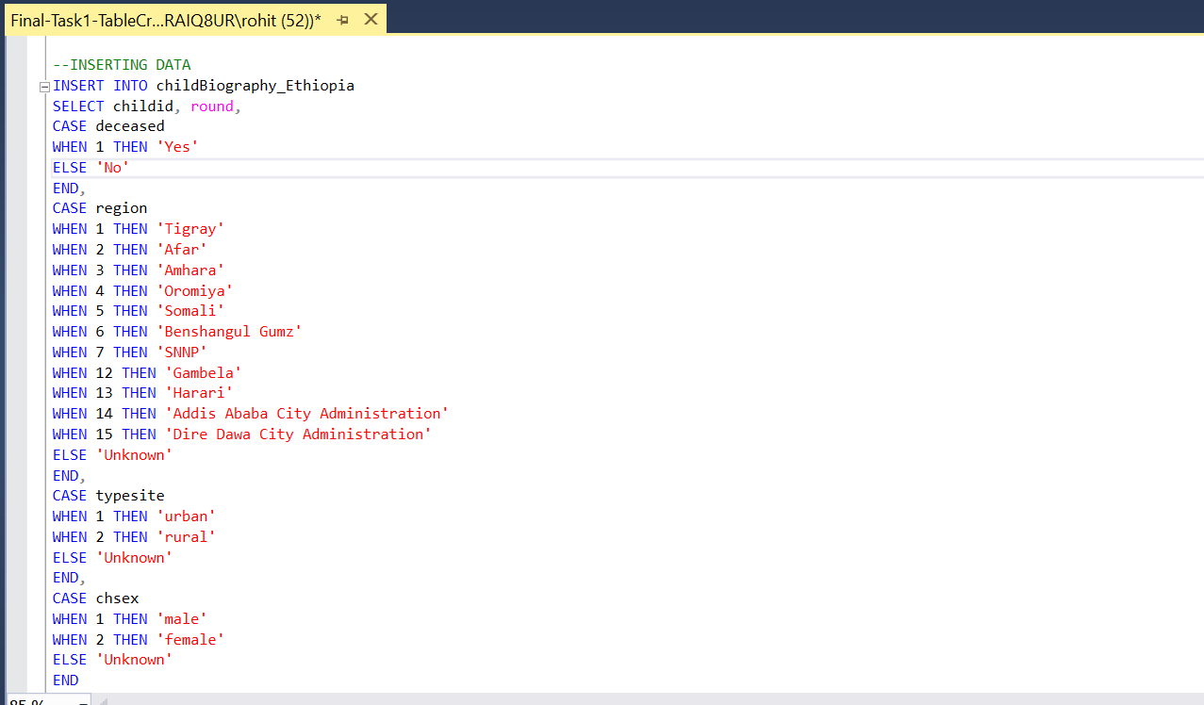

*Fig.4.2.*

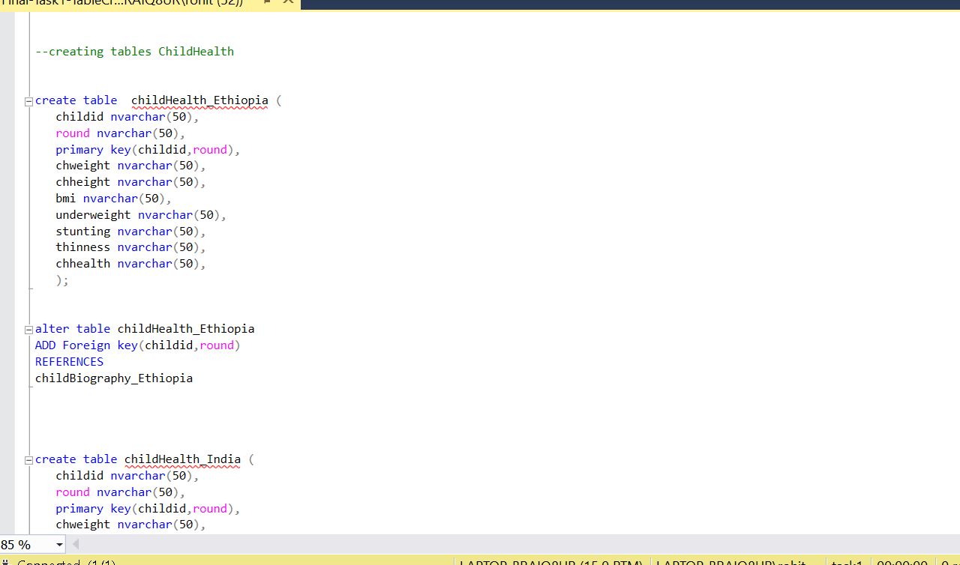

*Fig.4.3.*

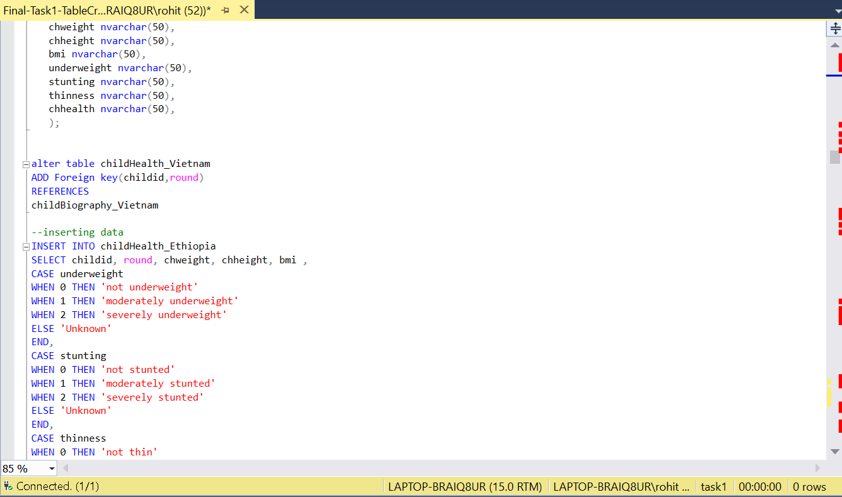

*Fig.4.4.*

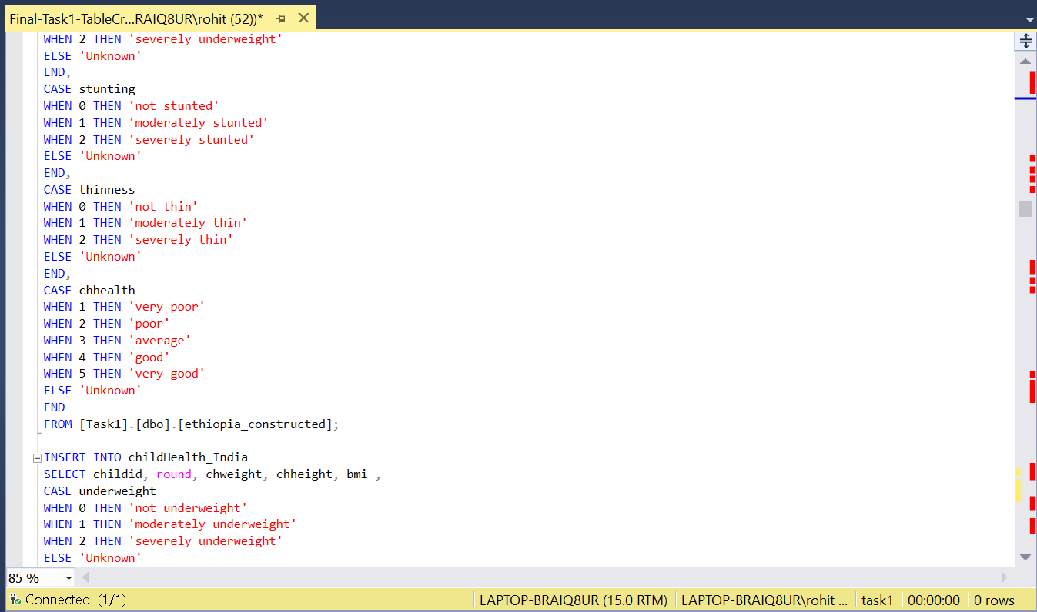

*Fig.4.5.*

*.*

1. **Database Normalisation:**

* First Normal Form (1NF) explains that Each table cell should contain a single value and Each record needs to be unique.
* Second Normal Form (2NF) has two rules:
  1. Rule 1- Be in 1NF
  2. Rule 2- Single Column Primary Key that does not functionally dependant on any subset of candidate key relation
* Second Normal Form (2NF) has two rules:

1.Rule 1- Be in 1NF

2.Rule 2- Single Column Primary Key that does not functionally dependant on any subset of candidate key relation

So with the help of the Reference that database was considered to be Normalized. Since we use Unique ID and Rounds As Primary Key.

1. **Transaction and Concurrency Control:**

ConcurrencyControl can simply be said to be executing multiple transactions at a time. The simultaneous execution of transactions over shared databases can create several data integrity and consistency problems. Lock guaranties exclusive use of data items to a current transaction

1. **Error Handling:**

The error’s can be handled with the help of Try and Catch Statement. When an error occurs inside the TRY block, the control moves to the first statement inside the CATCH block. On the contrary, if the statements inside a TRY block have completed execution successfully without an error, the control will not flow inside the CATCH block.

1. **T-SQL Statements:**

**Report 1:**

To find the Total Count of Death happened in India and Ethiopia Separately.

The following SQL, as nested Select Statement is used to get the Overall Counts of the Death Happened in India and Ethiopia.

SELECT (SELECT Count(DISTINCT Childid) from childBiography_India

WHERE deceased = 'yes') AS count_India,

(SELECT Count(DISTINCT Childid) from childBiography_Ethiopia

WHERE deceased = 'yes') AS count_Ethiopia

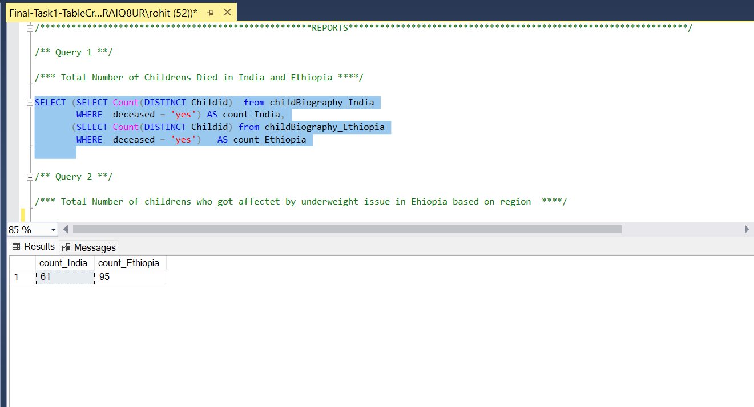

*Fig.8.1*

**Report 2:**

To Find out the Count of Total Children’s who got affected by Underweight Issue in Ethiopia and Select them according to Region’s.

**Code Explanation:**

This is Achieved by creating a View and Joining the two tables Child Biography and Child Health.

CREATE VIEW underweight_issue AS

SELECT c.childid, c.underweight,d.[region]

FROM childHealth_Ethiopia as c, childBiography_Ethiopia as d

WHERE c.childid = d.childid

create or alter view basedonRegion as

Select Count(Distinct Childid) as counts ,[region] from underweight_issue

where underweight = 'severely underweight'

group by [region]

select * from basedonRegion*Screenshot 2*

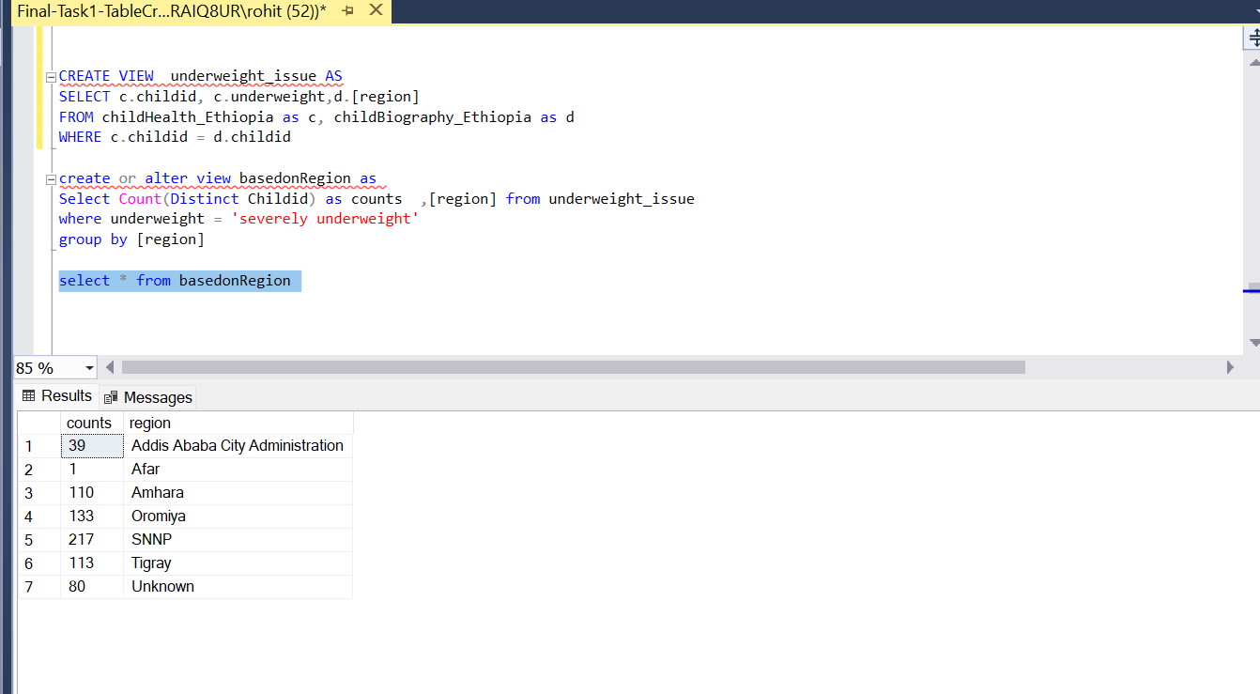

*Fig.8.2*

**Report 3:**

To get the count of Children’s who got affected by Stunting Issue in India and Peru

CREATE or alter VIEW stunting_issue AS

SELECT count(c.childid) as counts, c.stunting,d.chsex

FROM childHealth_India as c, childBiography_India as d

where c.childid = d.childid AND stunting = 'severely stunted'

group by stunting,chsex

select * from stunting_issue

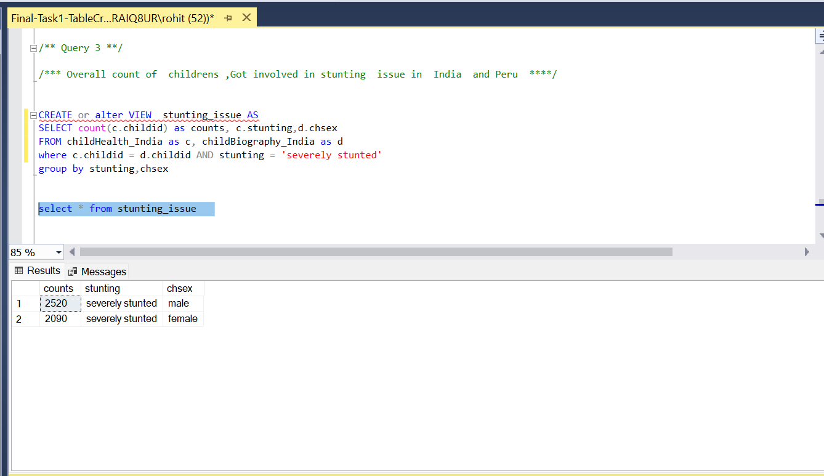

*Fig.8.3*

**REPORT 4:**

Number of Families Migrated in Peru Based on Regions

SELECT x.region, COUNT(DISTINCT x.childid) as [Count]

FROM (SELECT c.childid, c.region, d.Migrartion

FROM childBiography_Peru as c

FULL JOIN Tragedy_Peru as d

ON c.childid = d.childid) x

WHERE x.Migrartion = 'yes'

GROUP BY x.region;

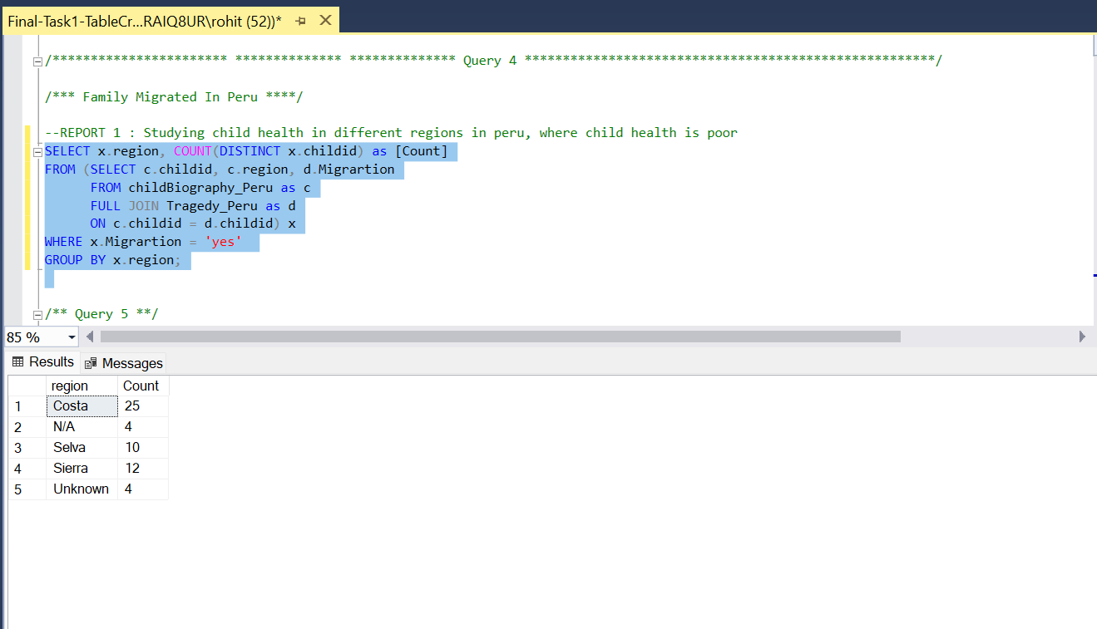

*Fig.8.4*

**REPORT 5:**

To Find the Families affected by Food Availability because of Crop Failure in Vietnam.

SELECT x.foodsec, COUNT(DISTINCT x.childid) as [Count]

FROM (SELECT c.childid,c.CropFailure,d.foodsec

FROM [Tragedy_Vietnam] as c

FULL JOIN EconomicStatus_Vietnam as d

ON c.childid = d.childid) x

where CropFailure = 'Yes'

GROUP BY x.foodsec ORDER BY Count;

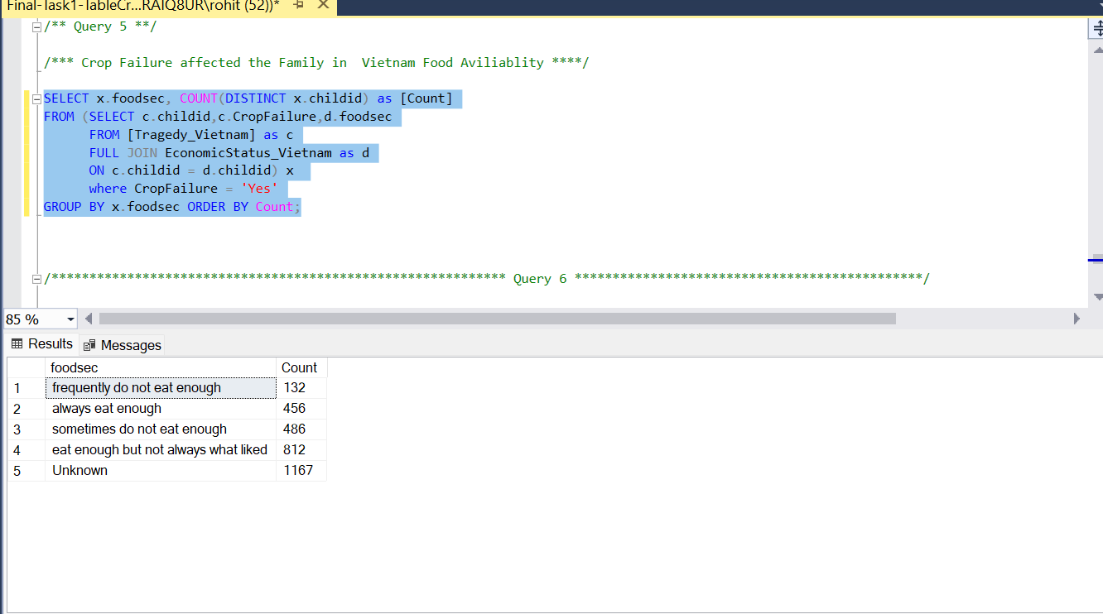

*Fig.8.5*

**Report 6:**

Finding out the number of children’s health is Poor based on BMI and the Round in Vietnam.

* creating Function to convert the float value to integer

create function dbo.kio(@opm float)

returns INT

AS

BEGIN

RETURN @opm

END

Select childid , dbo.kio(bmi) as BMI,round, chhealth from childHealth_Vietnam where chhealth = 'poor'

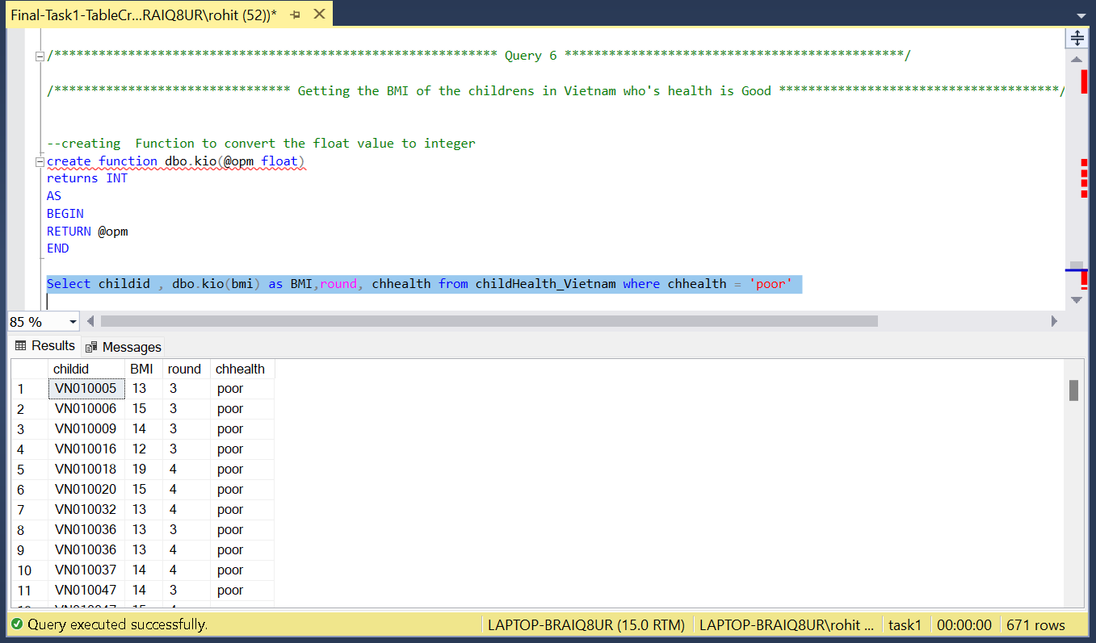

*Fig.8.6*

**Report 7:**

Getting a Report for counting the Less Food Availability in India based on region because of Natural Disaster.

CREATE or alter PROCEDURE lackOfFood_India

AS

BEGIN

SELECT e.region, COUNT(DISTINCT e.childid) AS [count]

FROM (SELECT c.childid, c.region, d.foodsec,f.NaturalDisaster,d.[DecreaseFoodAvailability]

FROM childBiography_India AS c

INNER JOIN EconomicStatus_India AS d ON c.childid =d.childid

INNER JOIN Tragedy_India AS F ON

F.childid = d.childid) e

WHERE [DecreaseFoodAvailability] = 'Yes'

AND NaturalDisaster = 'Yes'

GROUP BY e.region

END;

exec lackOfFood_India

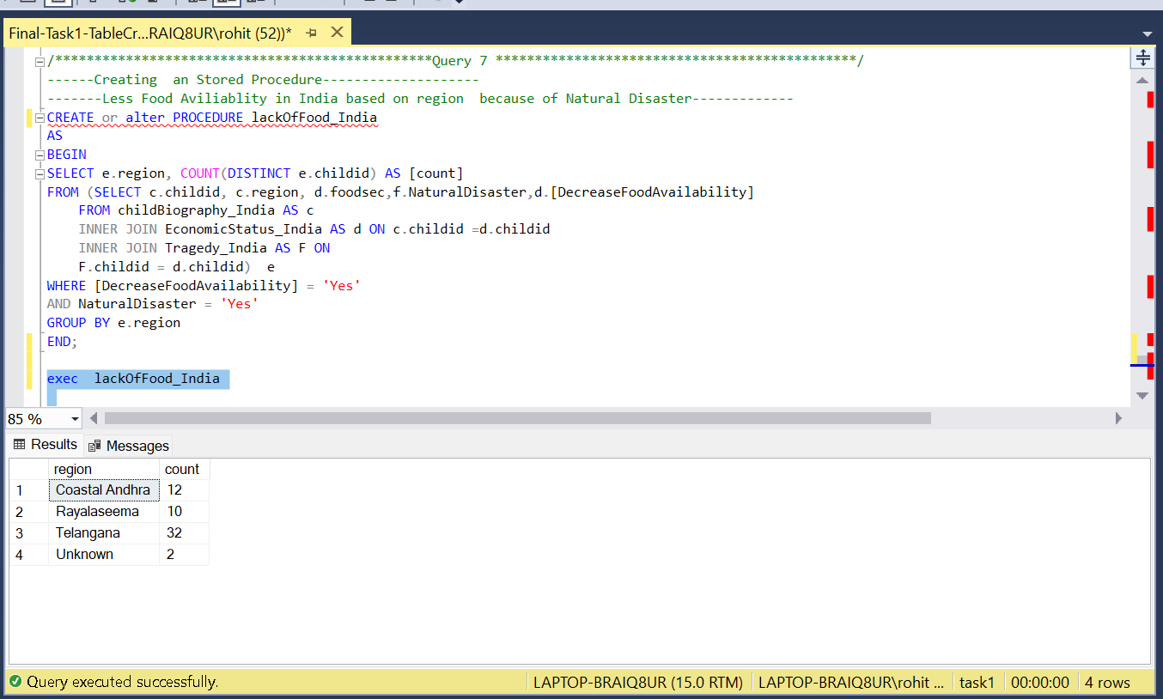

*Fig.8.7*

**Report 8:**

Getting the Count of Students who are affected by Stunting Issue because of Food Inaviliablity.

**Query:**

Create or alter view FoodsThiness1

as Select s.[childid],s.[foodsec] , y.[stunting]

from [childHealth_Peru] as y , [EconomicStatus_Peru] as s

where s.childid =y.childid and

[stunting] = 'severely stunted'

create or alter view FoodThiness2

as select count([stunting]) as counts ,[foodsec] from FoodsThiness1

group by [foodsec]

select * from FoodThiness2

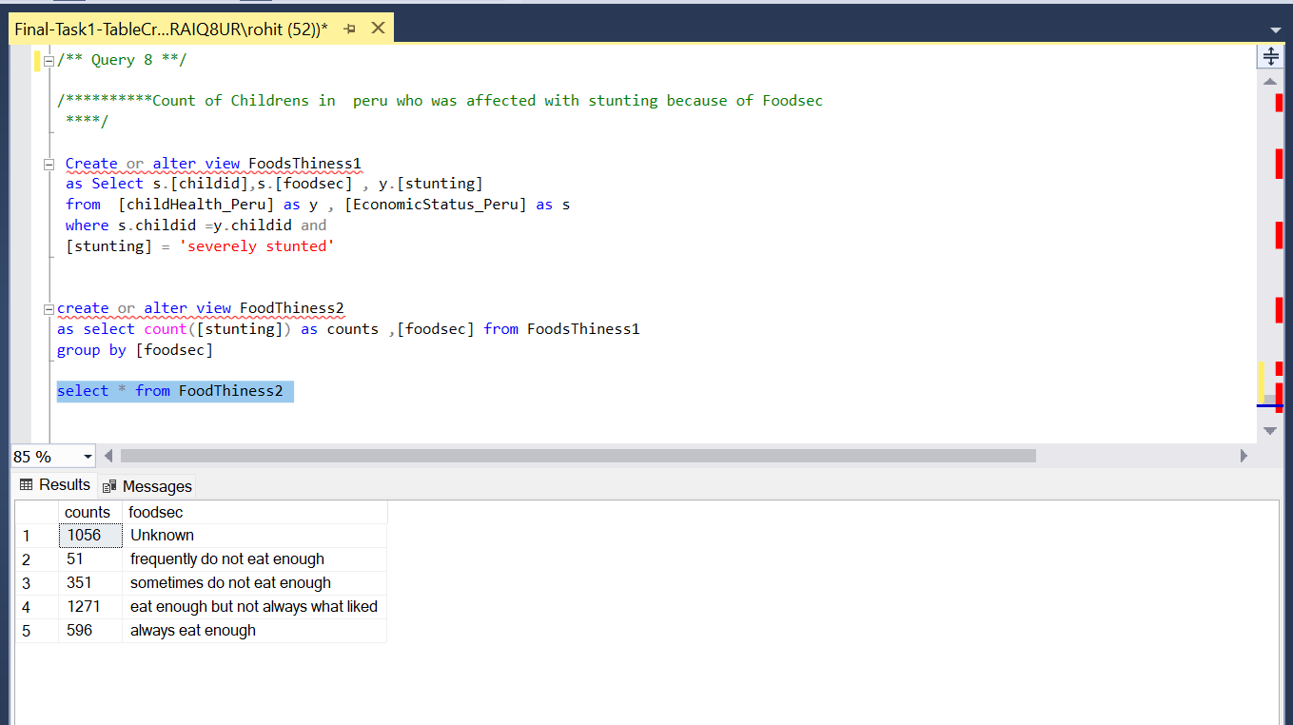

*Fig.8.8*

**8. Database Security**

In SQL-Server management, when creating a database or Importing the data it ask to get authorize. So by default it is clicked as Windows Authentication. There is one more authentication, SQL Server Authentication which configured as a system administrator. In this Task 1, Windows authentication was practised. Azure Login was used to setup with the data on the cloud.

**9. Database Backup and Restore Strategy:**

To avoid Data loss the database is backed up on every individual work or changes. This Backup file can be later used on other machine to continue the work from where we left with the help of restore option. The log-file is also backed Up, to know the status of the last Changes made. There is an option for automatic backup, based on Time Intervals.

**Steps for taking Backup:**

Right click on the Data-Base that you want to take a Backup and then choose task and then backup.

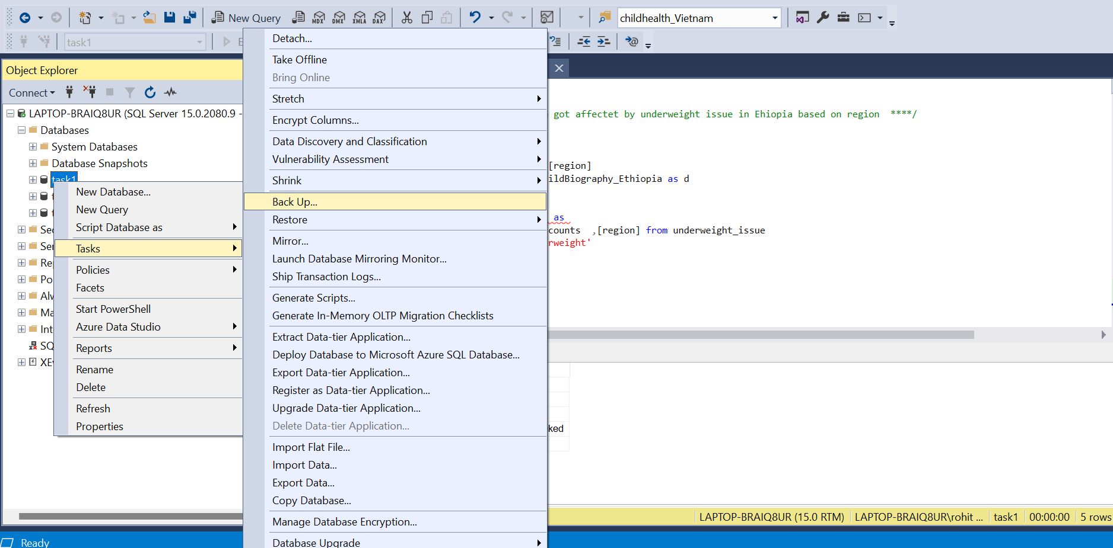

*Fig.9.1.*

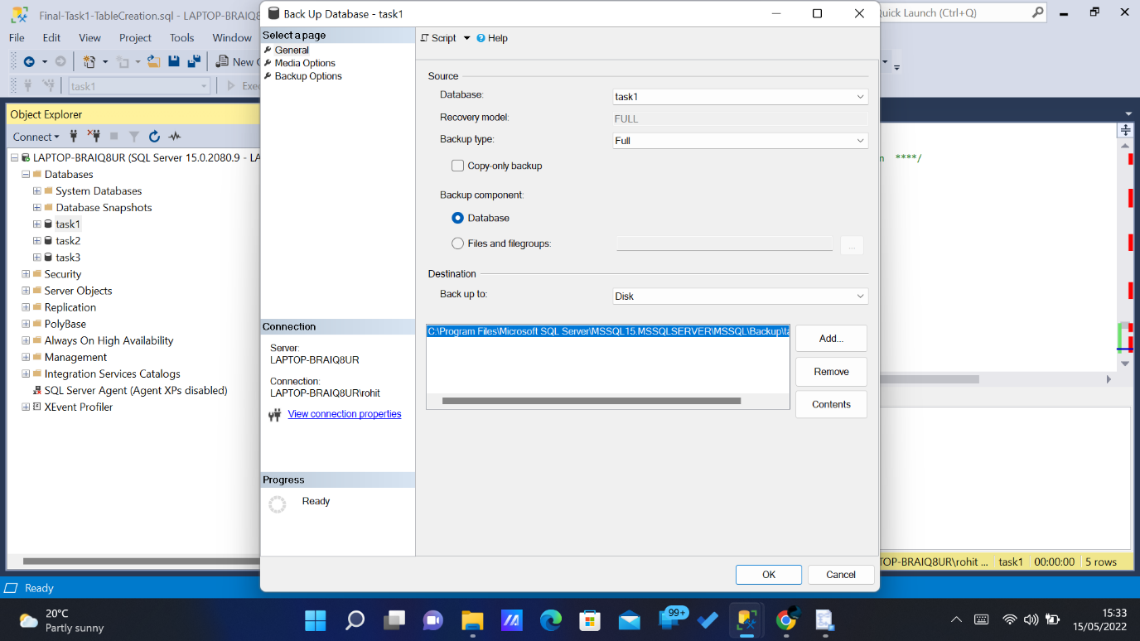

*Fig.9.2.*

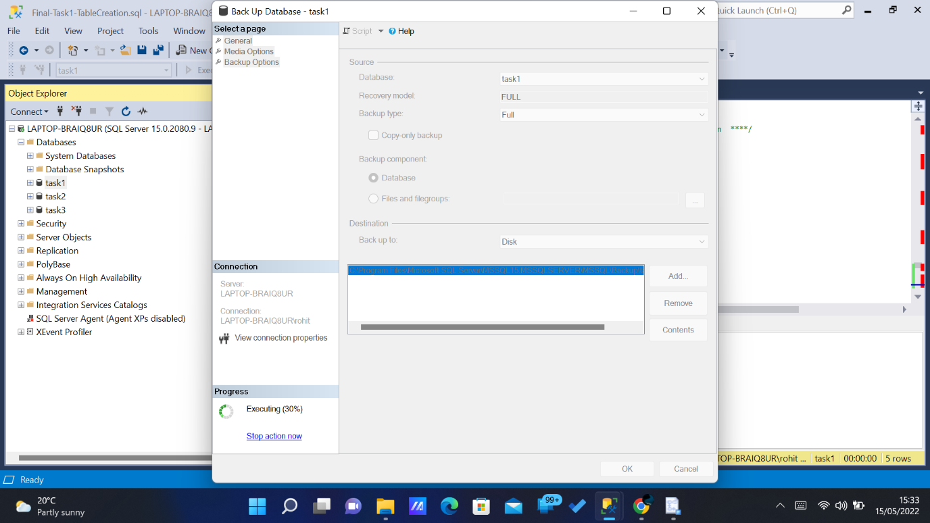

*Fig.9.3.*

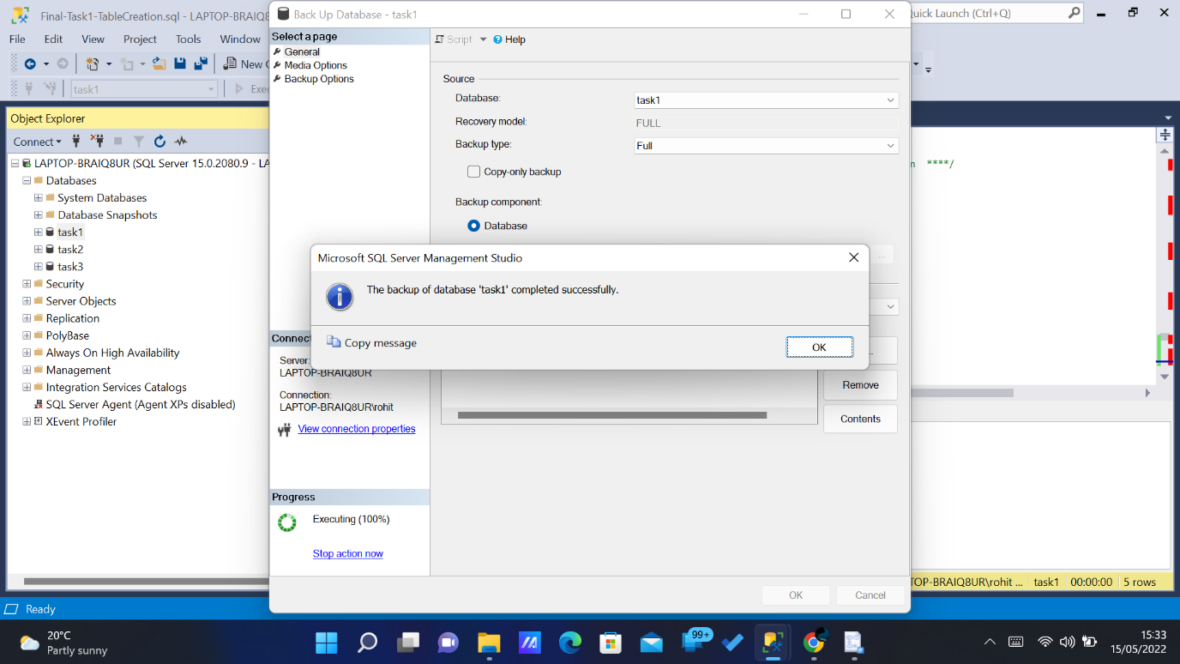

*Fig.9.4.*

**10. Data Privacy, Ethical and legal issues:**

Data privacy is another feature, which helps to hide the confidential details of the database for any organization. In this case, the database of Greater Manchester police has been required to develop for securing the data of every person such as police and criminal. Moreover, this has been utilized here to protect the data from the malware attacks and malicious attackers. The ethical issues corresponding to the creation of the database have been maintained to save the personal details of the police and criminal from the suspicious and unauthorized users. Further, the legal issues have also been dominated in the database to maintain every kind of legal agreement for protecting information.

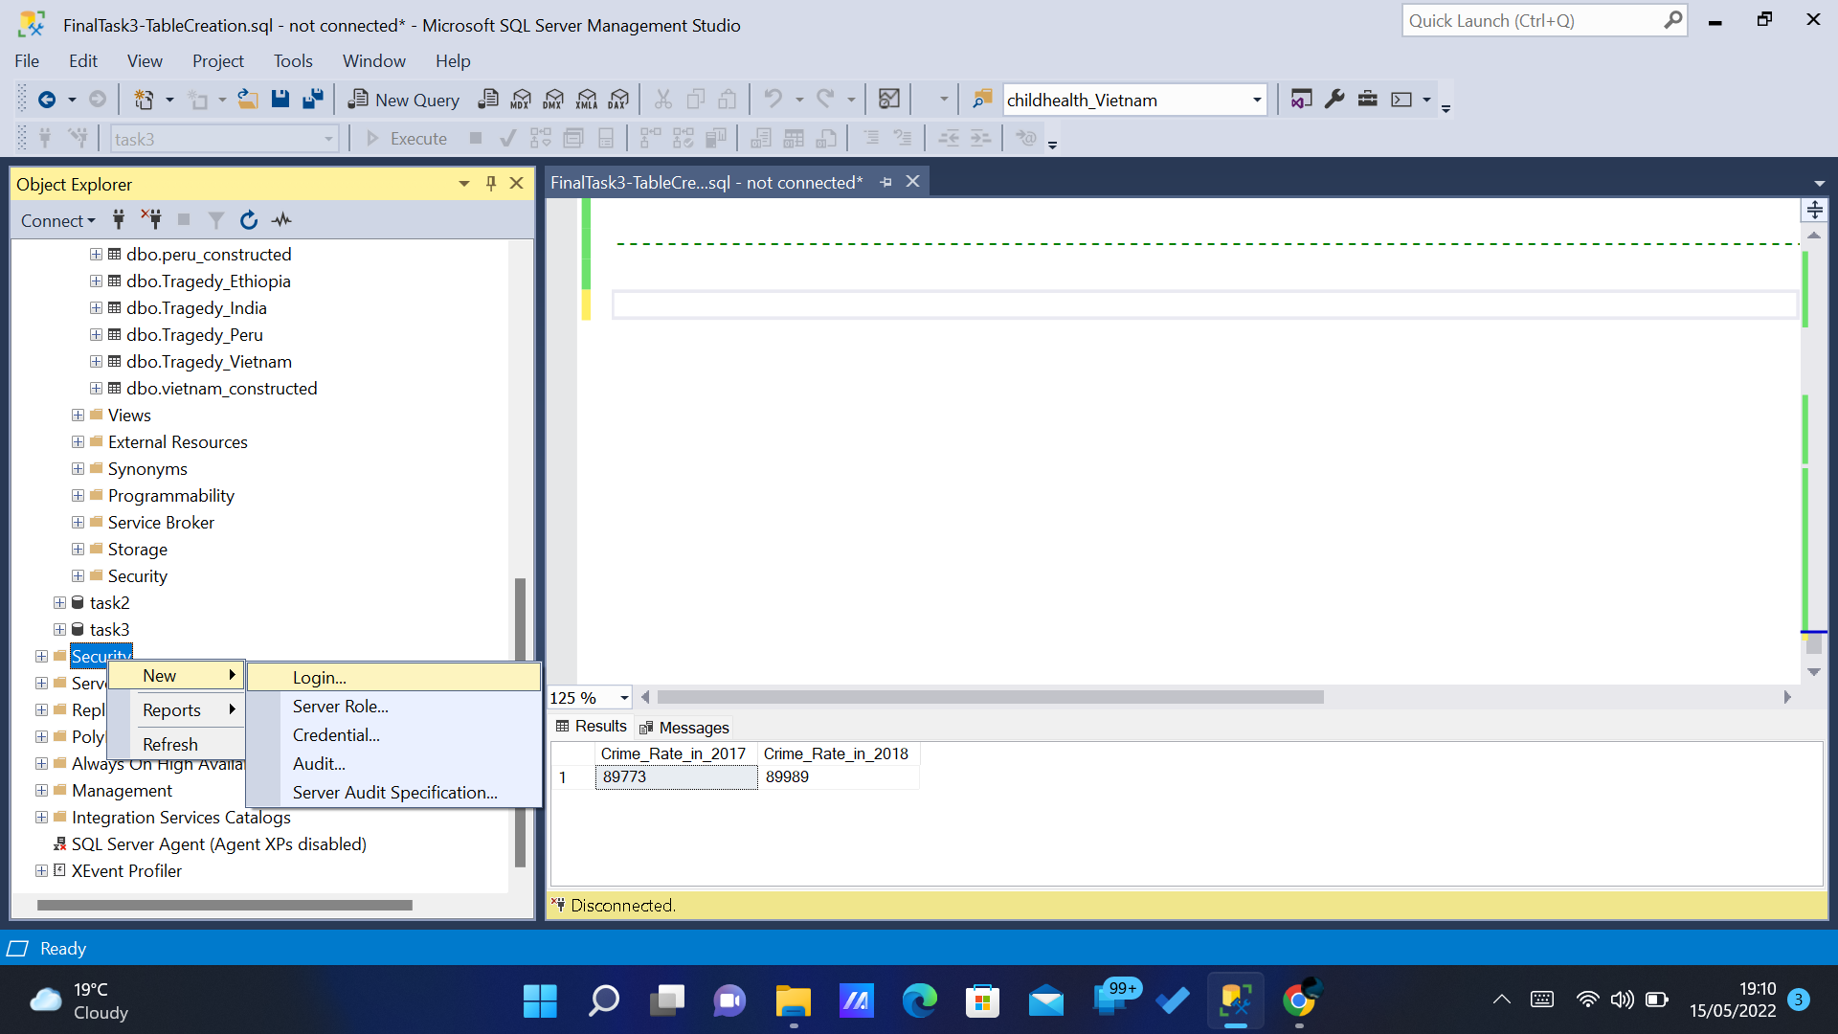

*Fig.10.1.*

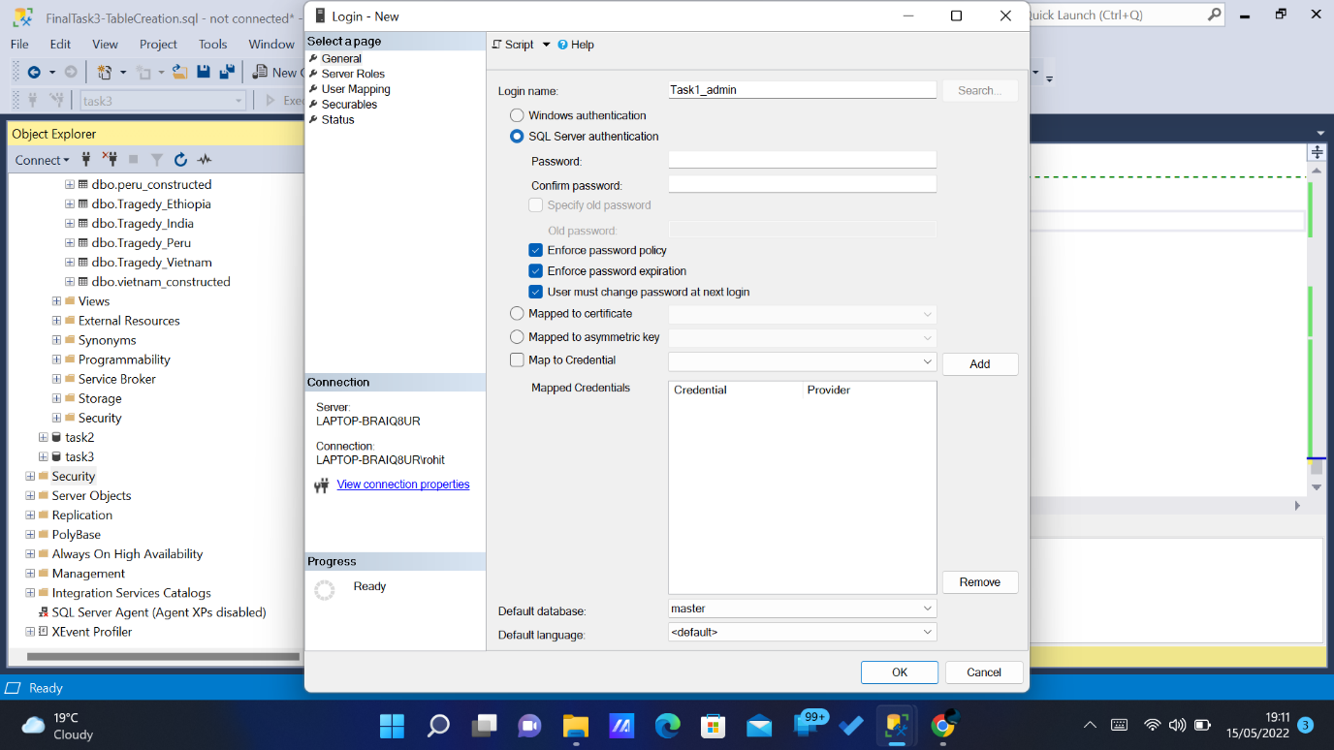

*Fig.10.2.*

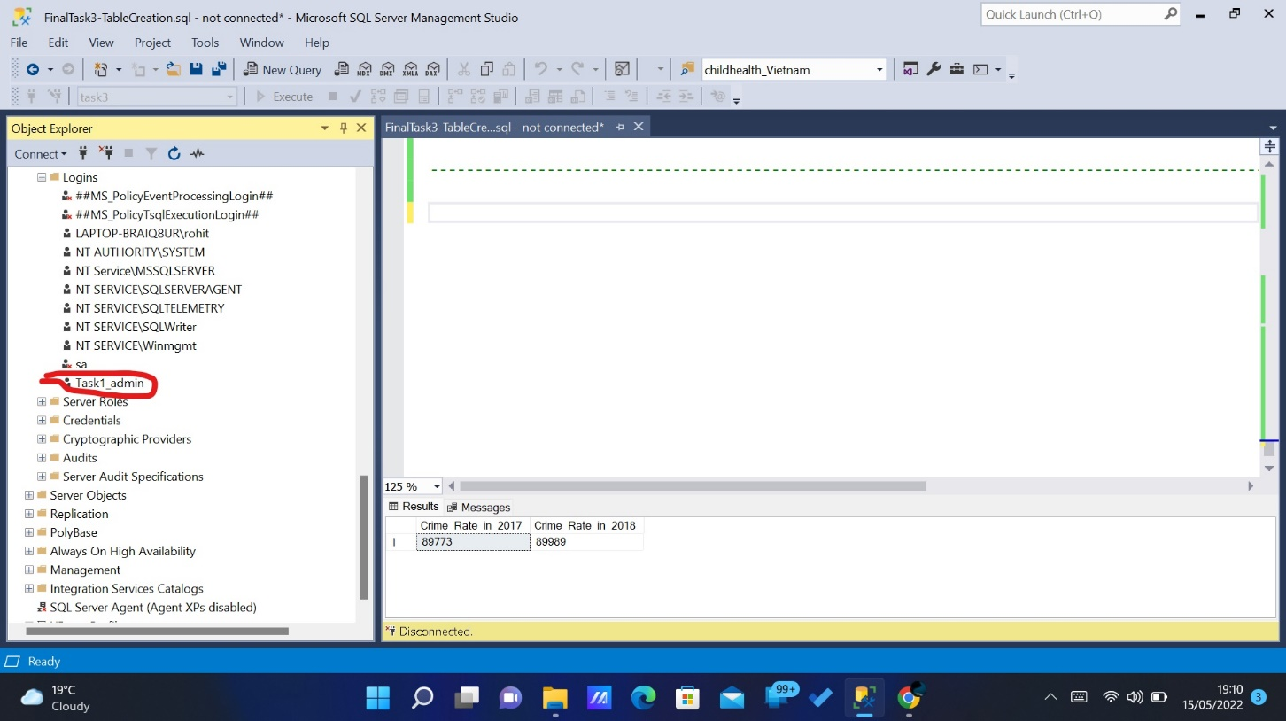

*Fig.10.3.*

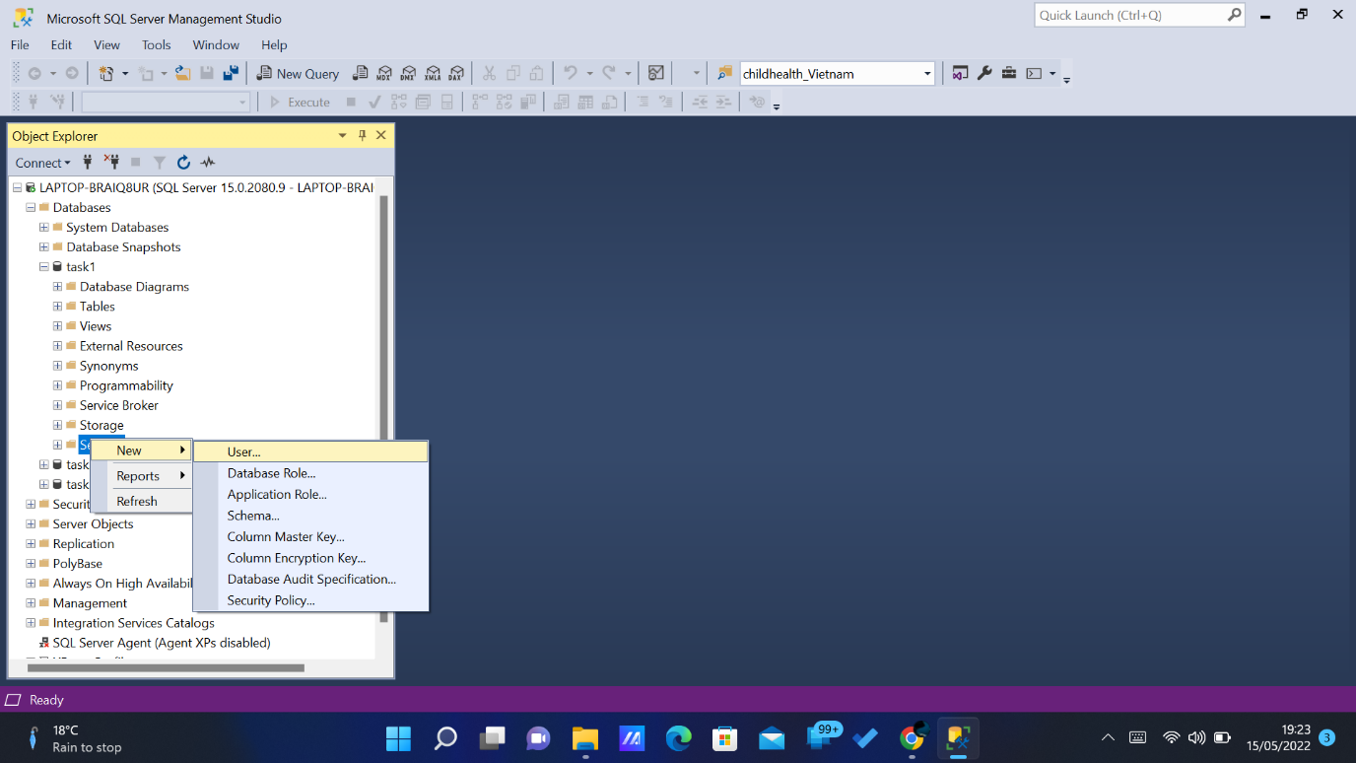

*Fig.10.4.*

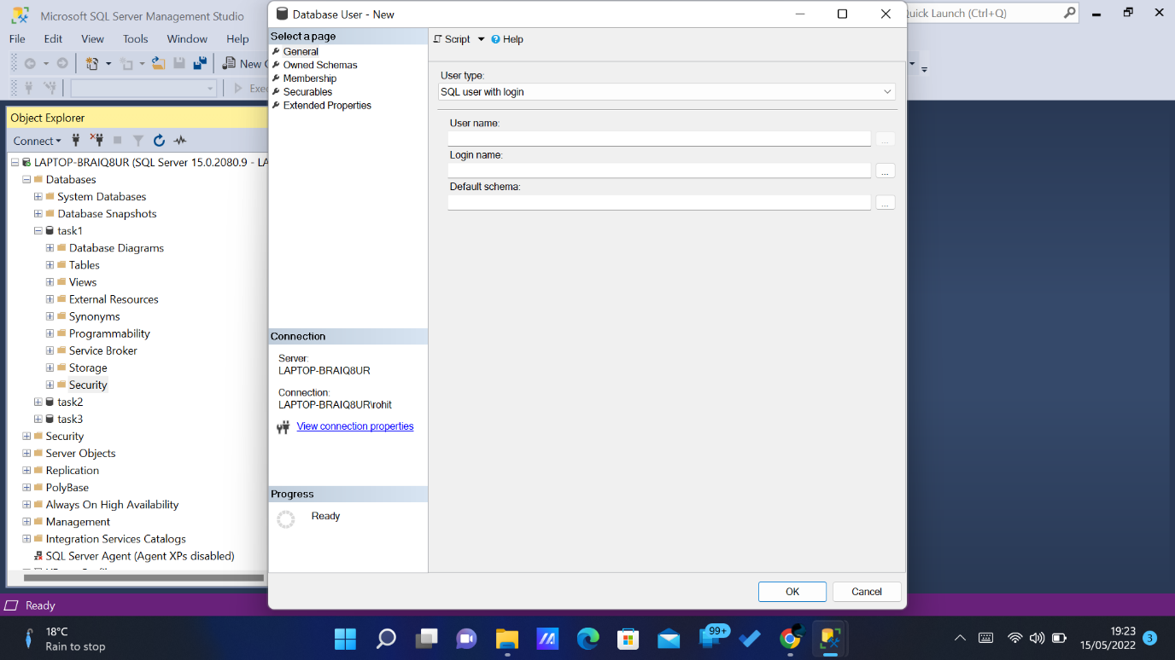

*Fig.10.5.*

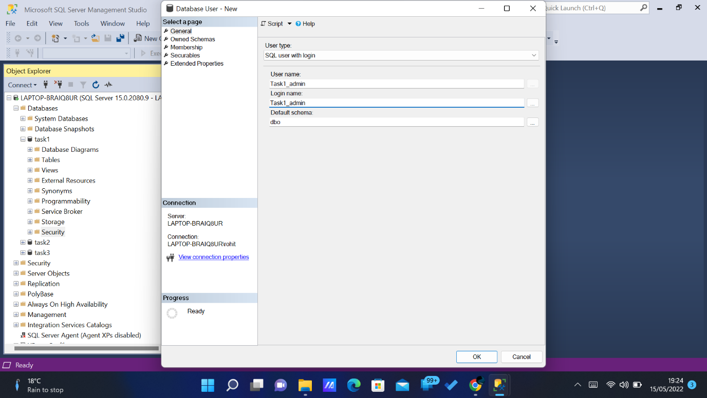

*Fig.10.6.*

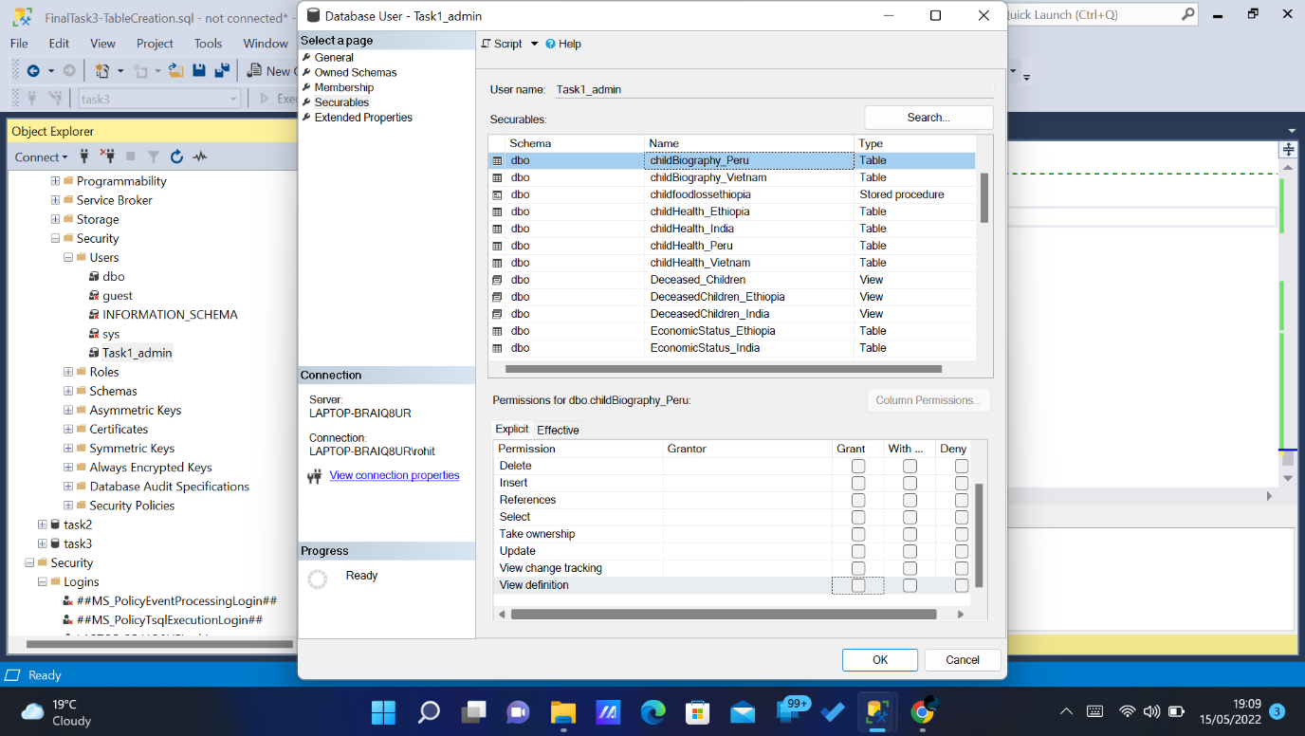

*Fig.10.7.*

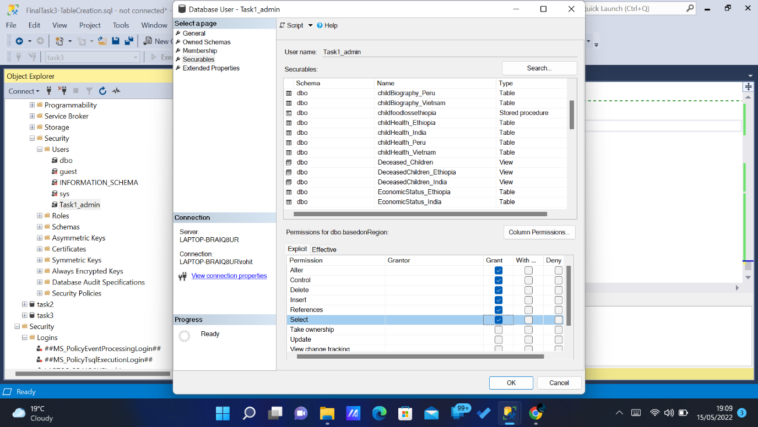

*Fig.10.8.*

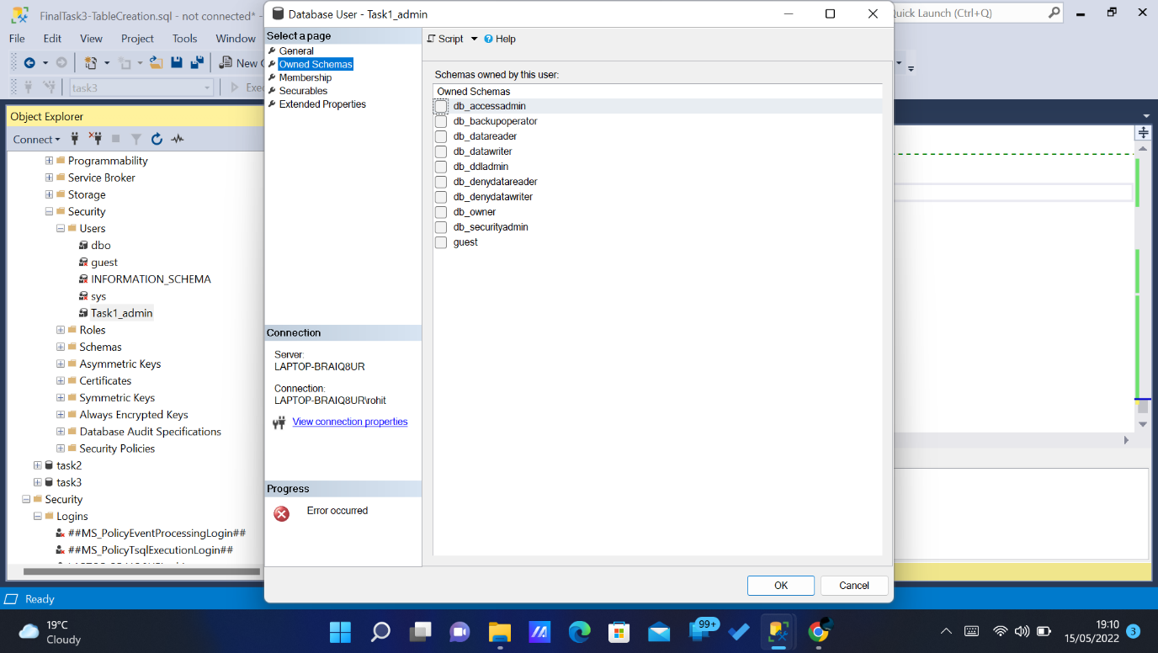

*Fig.10.9.*

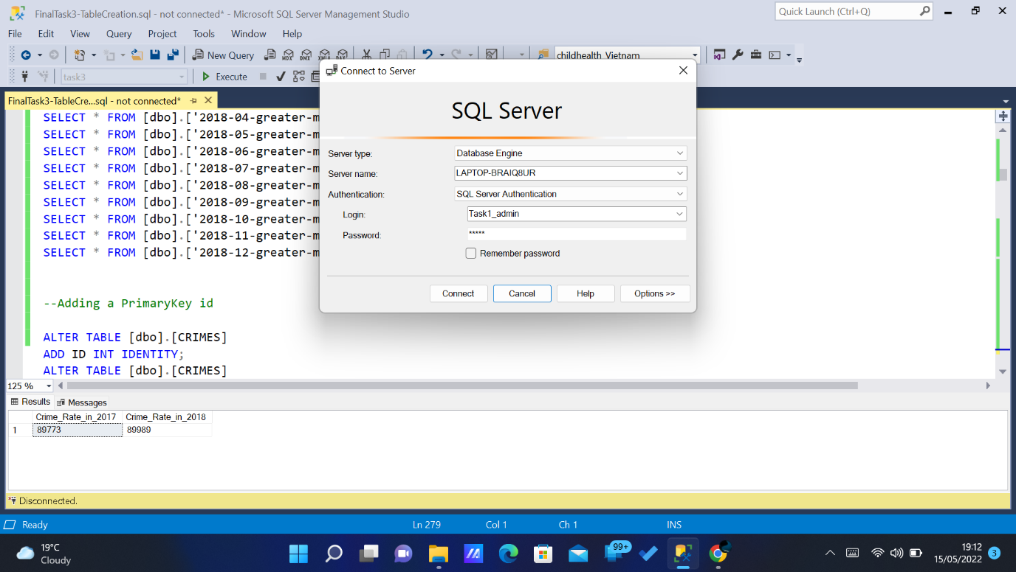

*Fig.10.10.*

**11. Conclusion**

As per the Reports made, it was clear that more than 250000 Children were getting affected with their health because of Food Aviliablity. The Following observation was concluded,

1. The Number of Children’s Died in Ethiopia was higher than all the other countries.
2. Stunting Issue was Higher among Male children’s in India.
3. Ethiopia has more health related problem’s and higher in literacy.
4. Food Aviliablity was less in India compared to the other countries according to regions.
5. Because of less Food Aviliablity , increase in the health problems of the children in Peru.

**TASK 2**

1. **Abstract:**

The Second Task is to measure the inequality in the education sector of Lower Income Family children’s in Vietnam. The data was downloaded in two forms as wave 1 and wave 2. Both files have separate data’s , so it was merged with some columns and created a new tables to get a overview result.

1. **Introduction:**

The data was proposed in the year 2016 – 2017 which was one year. So the data was partioned between these years as wave 1 and wave 2. The wave 1 as the main data which represent’s child personal details and wave 2 which represents additional info

1. **Design Rationale:**

To join the two data’s Unique ID was taken as a primary key.

1. **Tool and Programming Languages:**
2. Microsoft SQL Server Management Studio was used for configuring and Managing the Data.
3. TSQL Was used for writing Queries.
4. Microsoft Excel – For Creating Reports.
5. **Data Source:**

The Data was Downloaded from the Link below:

<https://beta.ukdataservice.ac.uk/myaccount/data/projects/project-lead?id=ad523f68-e35d-4506-873f-da736011254a#!/datasets>.

1. **Design** **Considerations** **and Table Creation.**

Primary key was set to these tables. Unique was taken as a primary key. In some table School ID is also set a Primary key. There are 6 tables created with the both wave 1 and wave 2 values. The first two tables with only wave 1 and The final table with both wave 1 and wave 2.

1. childIndex
2. studyAccess
3. schoolAccess
4. recordedIssues
5. feeException
6. childAcceptance

The values were inserted to the tables with the help of (Insert Into) Command. **Using the Meta Data Given the values were type-casted while Inserting. Case statement was used**. This gives more readability for the Front-End Developer and the users.

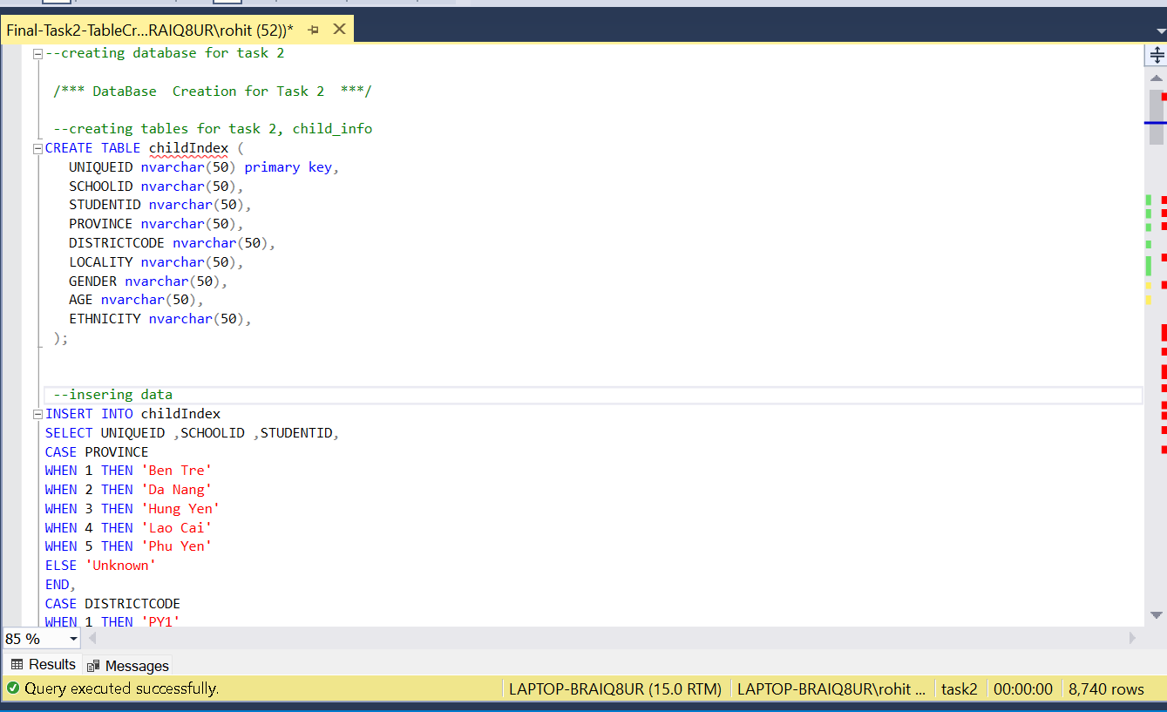

*Fig.6.1.*

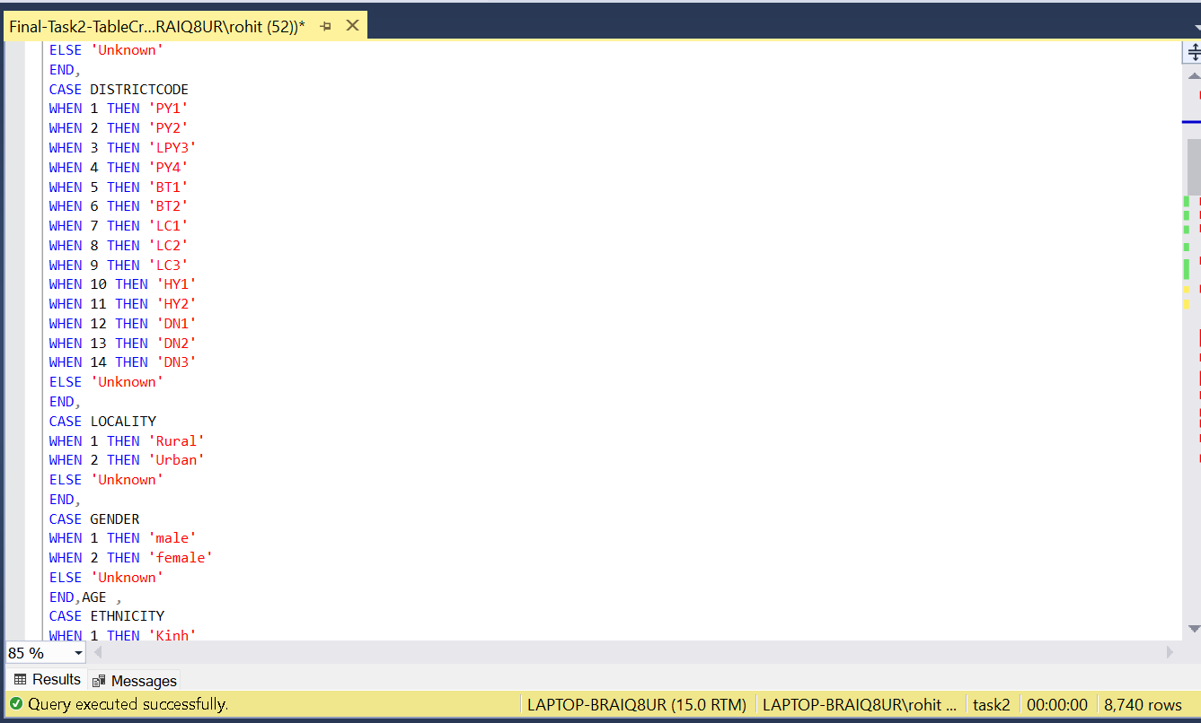

*Fig.6.2.*

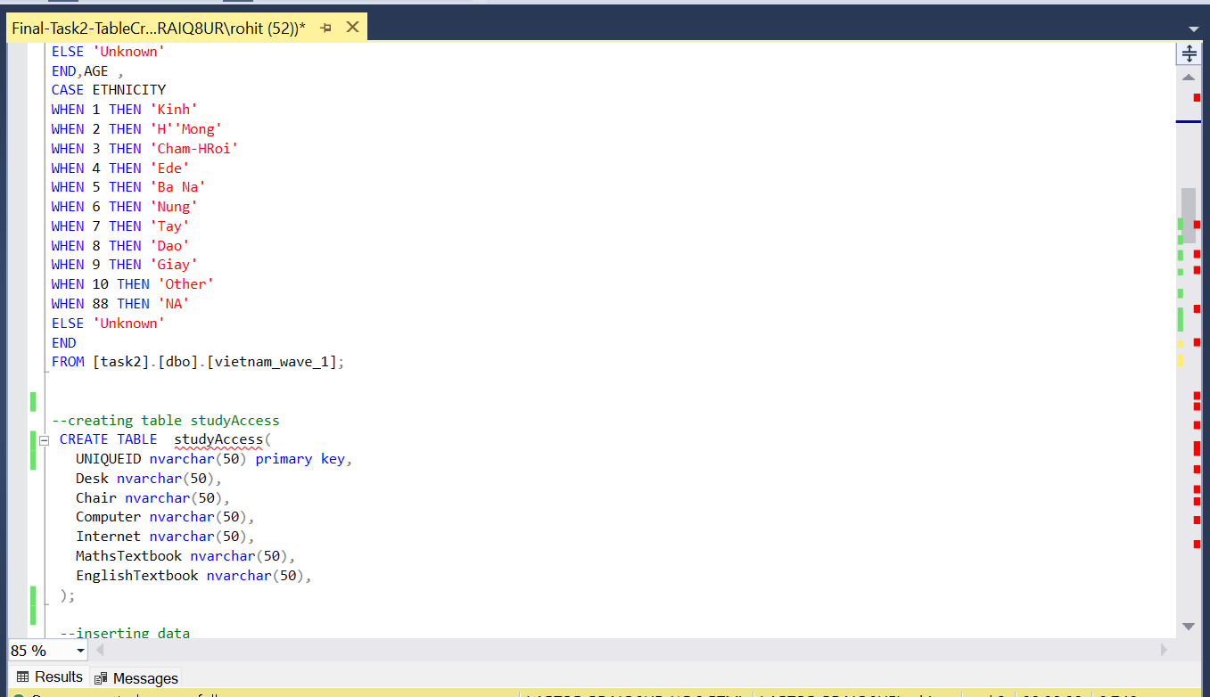

*Fig.6.3.*

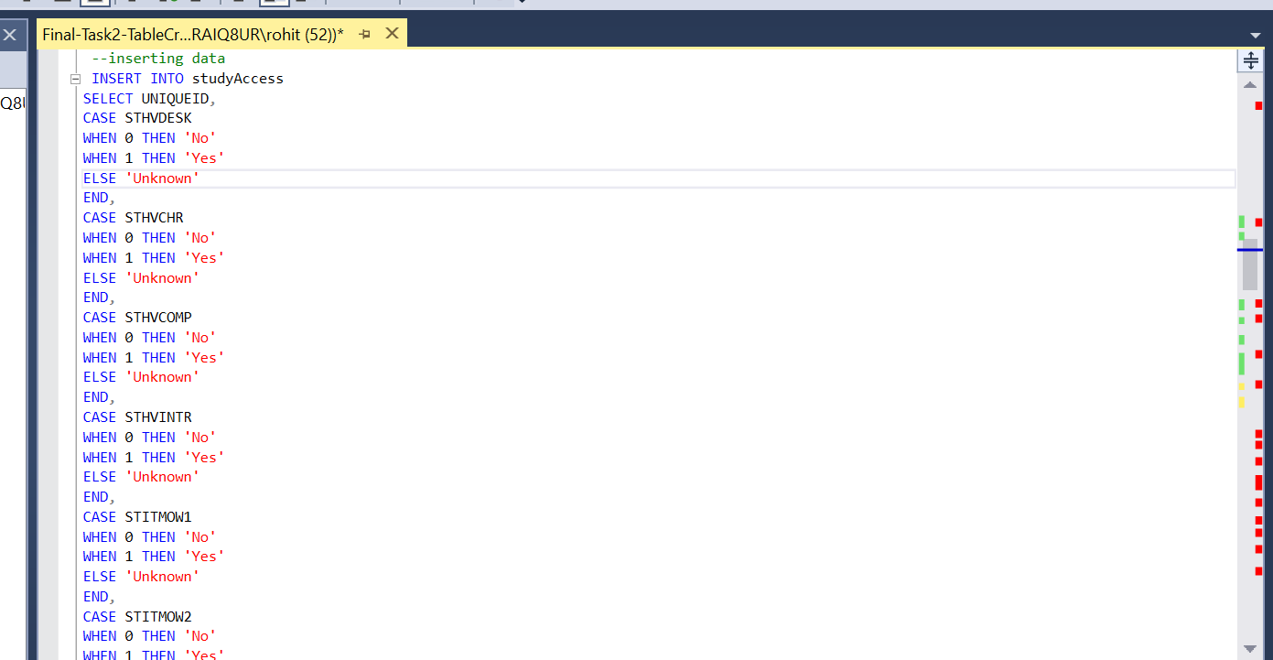

*Fig.6.4.*

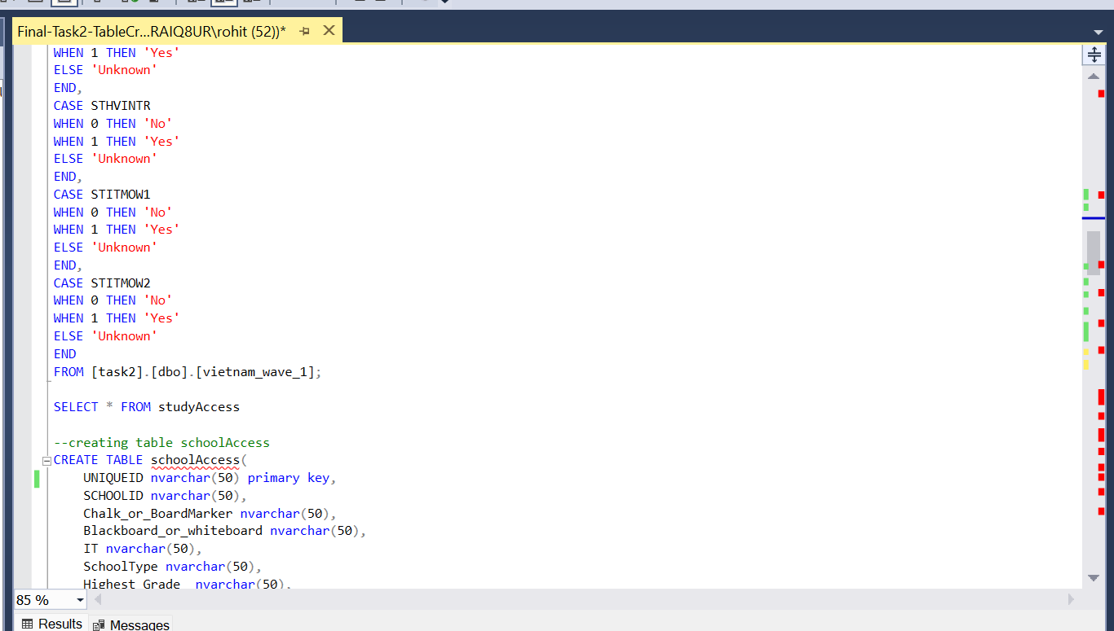

*Fig.6.5*

*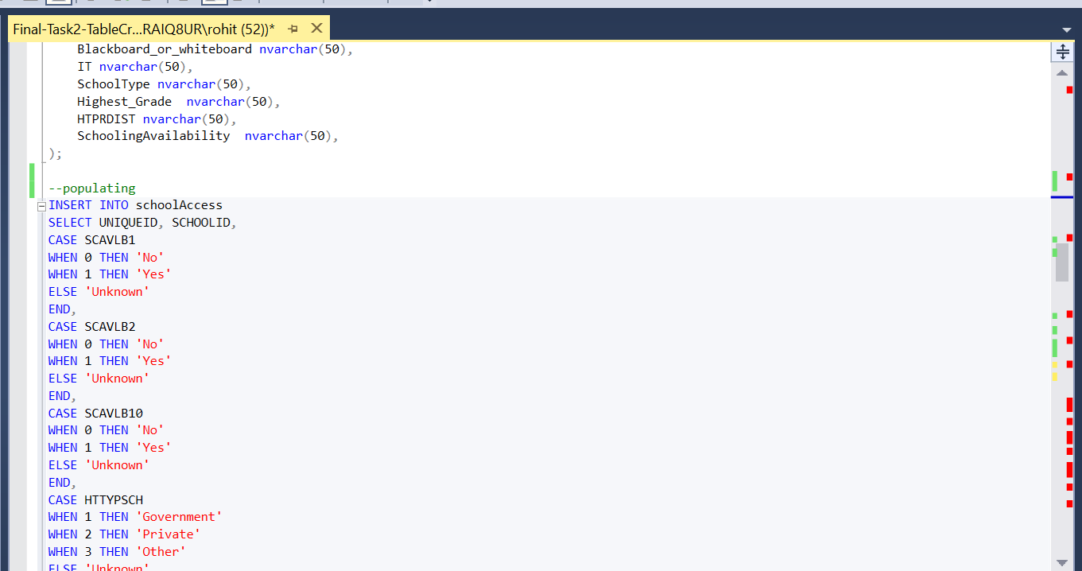 Fig.6.6*

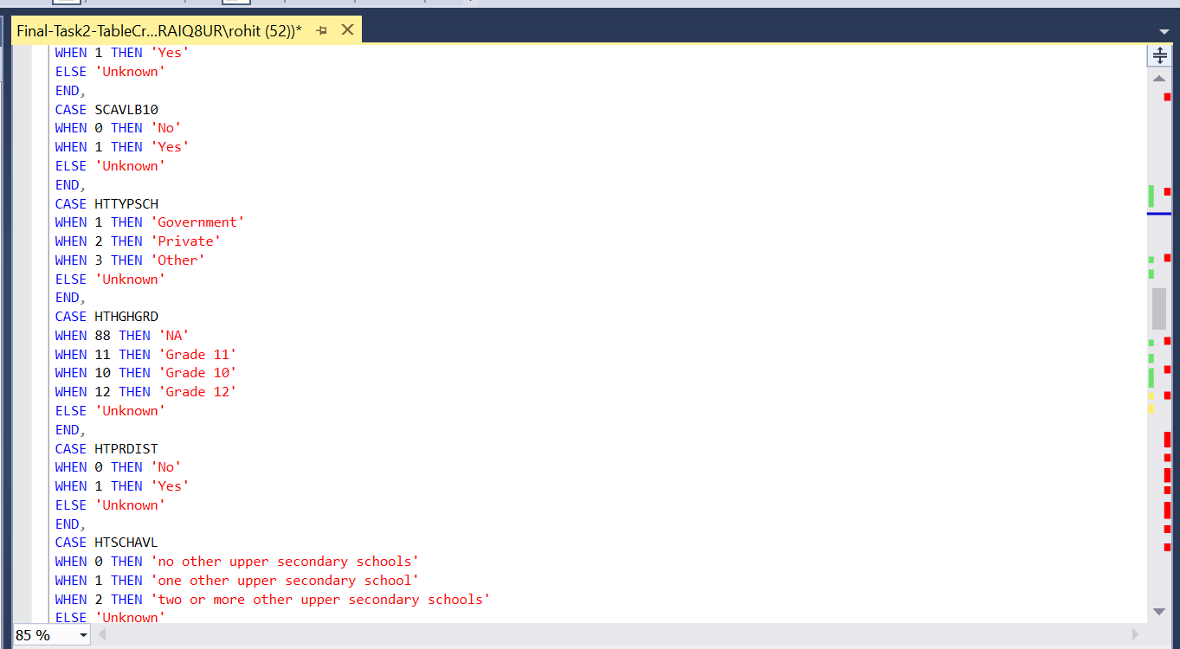

*Fig.6.7*

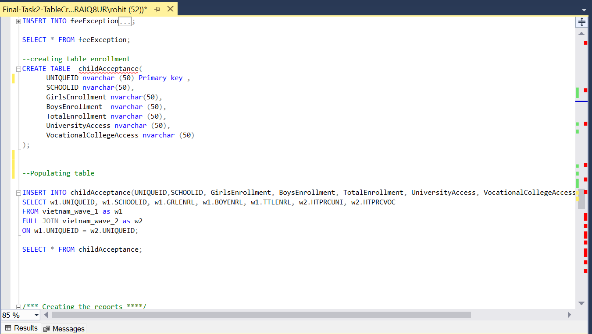

*Fig.6.8*

1. **T-SQL Statements:**

**Query 1:**

To find the Count of Government School as per Provience.

Create OR ALTER VIEW govenmentSchool as

Select p.[SchoolType] ,g.[PROVINCE]

from childIndex as g,schoolAccess as p

where g.UNIQUEID = p.UNIQUEID

Create OR ALTER VIEW Governmentschoolcount_location as

select count( SchoolType) as counts ,[SchoolType],PROVINCE from govenmentSchool group by PROVINCE,[SchoolType]

select * from Governmentschoolcount_location order by counts desc

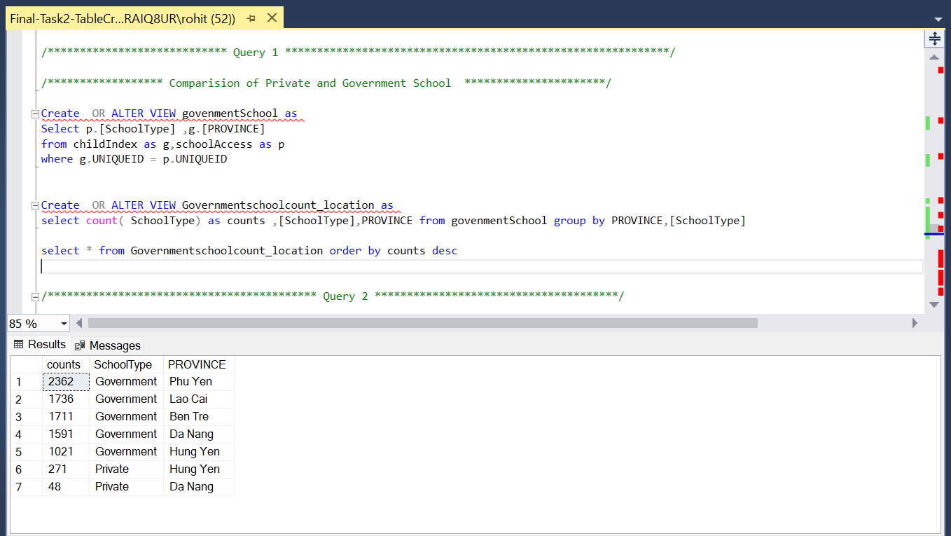

*Fig 7.1*

**Query 2:**

Locality wise females count

Create OR ALTER VIEW countoffemales_Locality as

Select LOCALITY , count(UNIQUEID) as Counts from childIndex where GENDER = 'female' Group by LOCALITY

select * from countoffemales_Locality

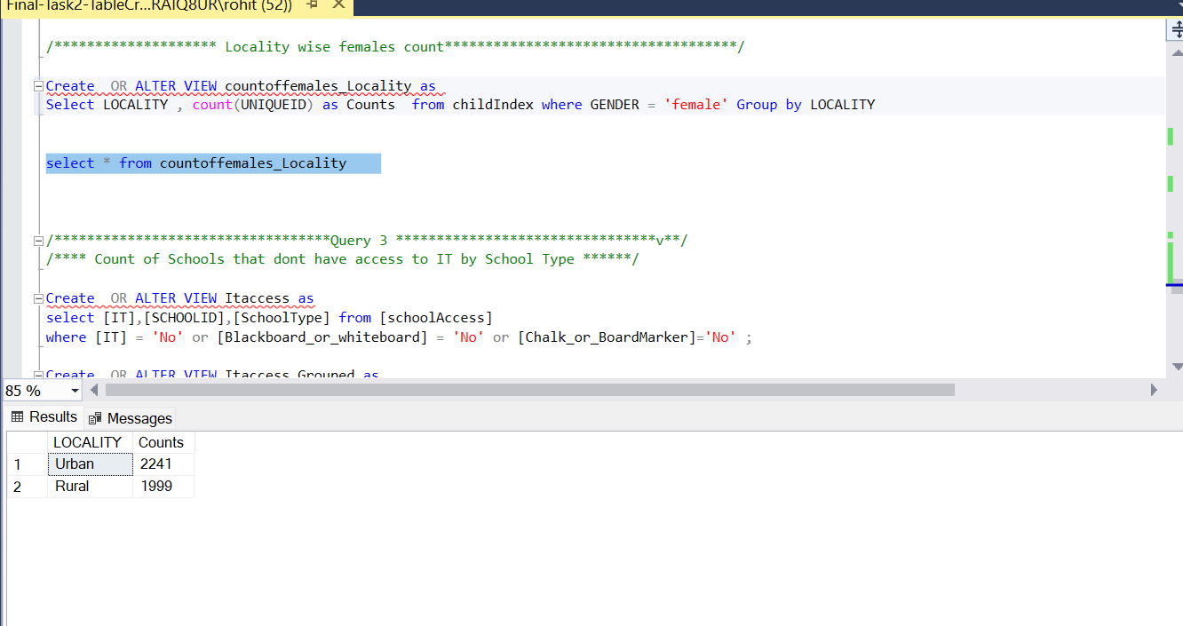

*Fig 7.2*

**Query 3:**

Count of Schools that don’t have School necessary by School Type.

Create OR ALTER VIEW Itaccess as

select [IT],[SCHOOLID],[SchoolType] from [schoolAccess]

where [IT] = 'No' or [Blackboard_or_whiteboard] = 'No' or [Chalk_or_BoardMarker]='No' ;

Create OR ALTER VIEW Itaccess_Grouped as

Select COUNT(DISTINCT SCHOOLID) as count ,SchoolType from Itaccess group by SchoolType

select * from Itaccess_Grouped

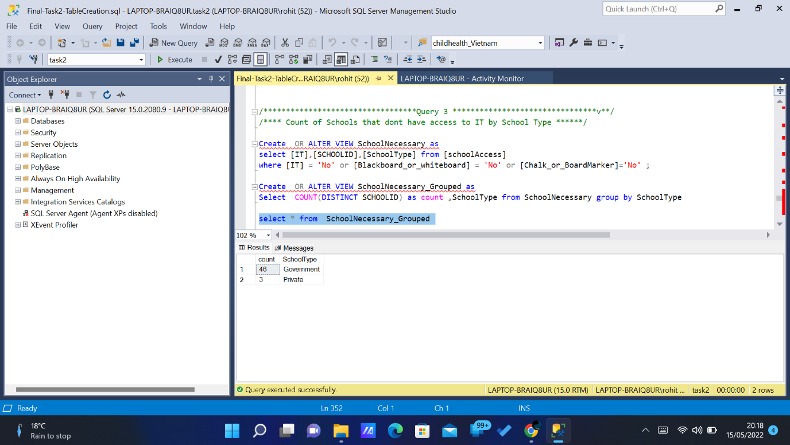

*Fig 7.3*

**Query 4:**

Getting Count of Government and private school

Create View SchoolTypeCount

As

Select(Select count(SchoolType) from schoolAccess WHERE SchoolType='Government') as GovernmentSchoolCount,

(Select count(SchoolType)from schoolAccess WHERE SchoolType='Private') as PrivateSchoolCount

select * FROM SchoolTypeCount

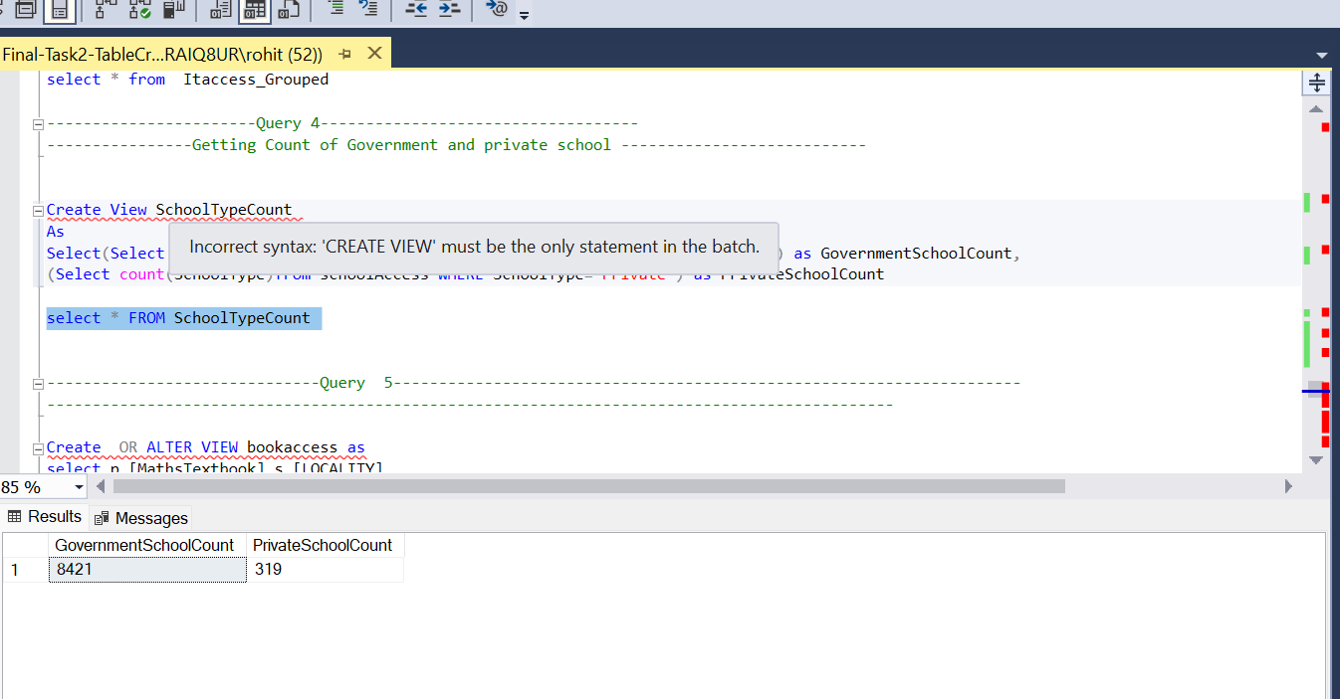

*Fig 7.4*

**Query 5:**

Count of Math Book-Access by Locality

Create OR ALTER VIEW bookaccess as

select p.[MathsTextbook],s.[LOCALITY],

count(p.[UNIQUEID]) as counts from [studyAccess] as p, [childIndex] as s

where [MathsTextbook] = 'No'

and s.[UNIQUEID] = p.[UNIQUEID]

group by [LOCALITY],[MathsTextbook]

Create OR ALTER VIEW MathbookaccessByLocality as

select counts,LOCALITY from bookaccess

SELECT * FROM MathbookaccessByLocality

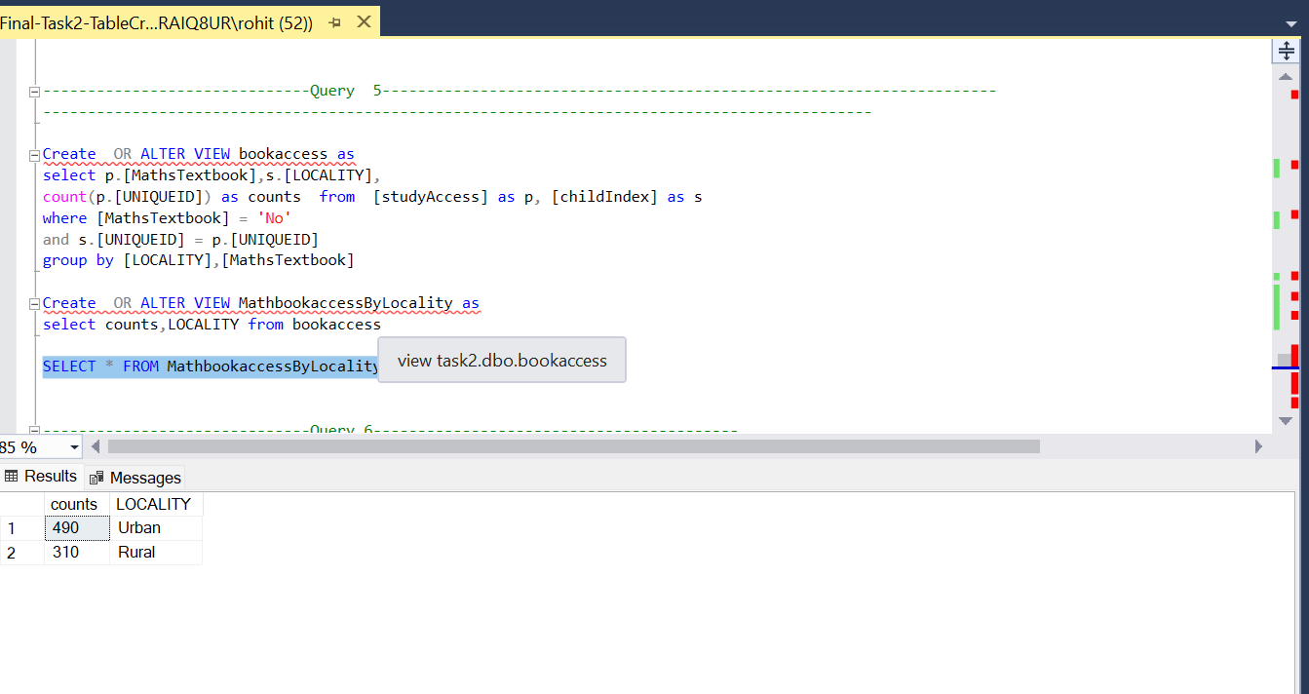

*Fig 7.5*

**Query 6:**

Count of childrens not gone to school becuase of work based on Ethinicty.

Create OR ALTER VIEW PaidWorkChildren as

select count([PaidWork]) as PaidWorkChildrens_Count,y.[ETHNICITY] from [childIndex] as y ,[recordedIssues] as s

where [PaidWork]= 'yes' and y.[UNIQUEID] = s.[UNIQUEID]

group by [ETHNICITY]

select * from PaidWorkChildren

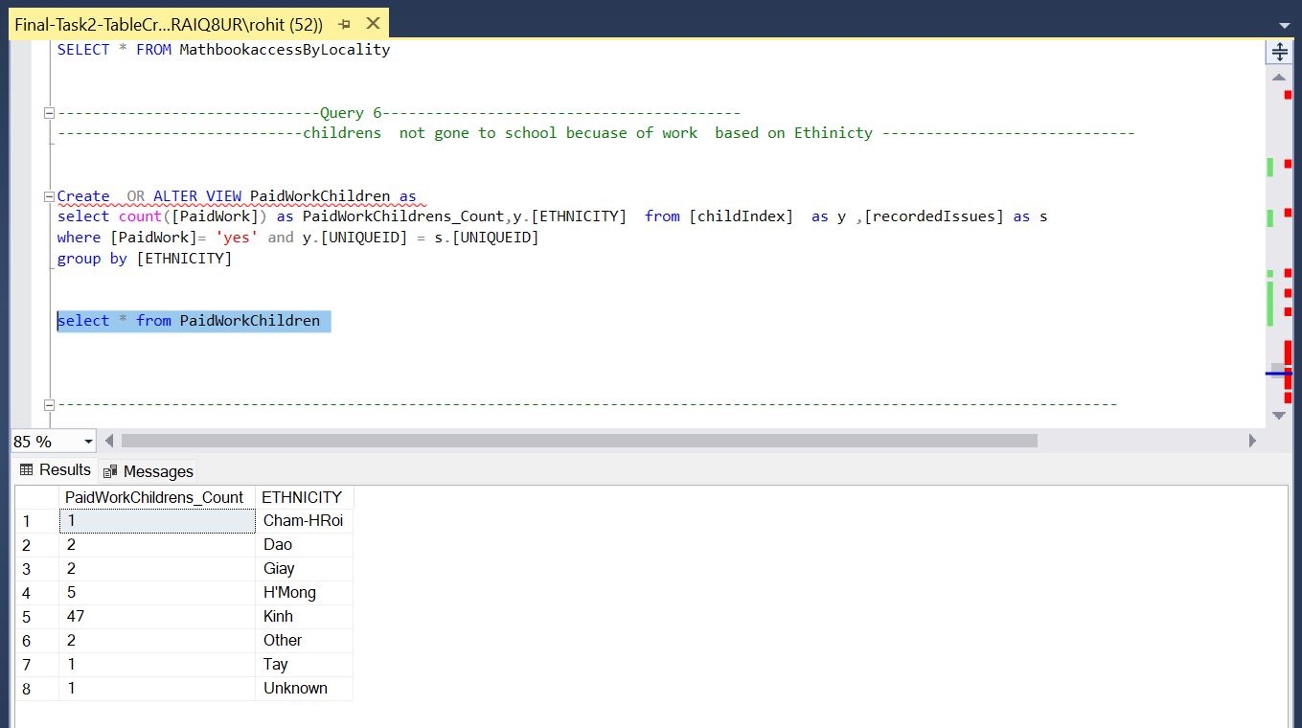

*Fig 7.6*

**Query 7:**

Count of Fee Exception based on remote area and ethnic minority

CREATE OR ALTER PROCEDURE FeeExcpetions @EthinicMinority nvarchar(30), @RemoteArea nvarchar(10)

AS

SELECT COUNT(O.[UNIQUEID]) as Counts,L.[PROVINCE] FROM [feeException] AS O ,[childIndex] as L WHERE

O.EthinicMinority = @EthinicMinority AND O.RemoteArea = @RemoteArea AND O.[UNIQUEID] = L.[UNIQUEID]

group by [PROVINCE]

EXEC FeeExcpetions @EthinicMinority = 'Yes', @RemoteArea = 'Yes';

select * from FeeExcpetions

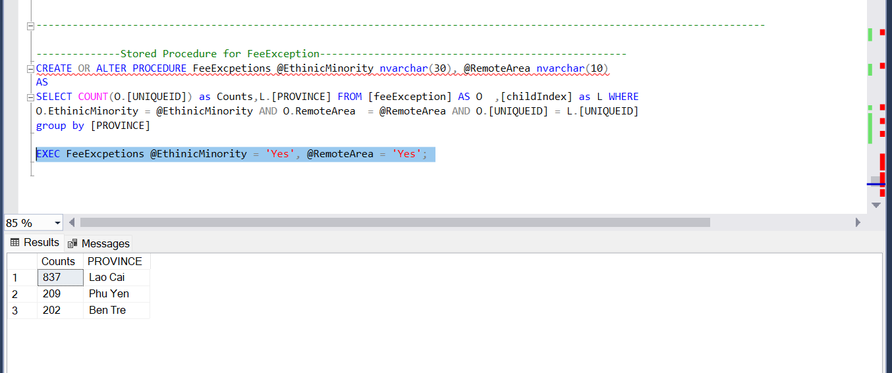

*Fig 7.7*

1. **Report Design:**

Microsoft Excel was used for creating the reports. The SQL server Was Connected to the Microsoft Excel. Then the Database was Selected for creating the reports with the help of Views.

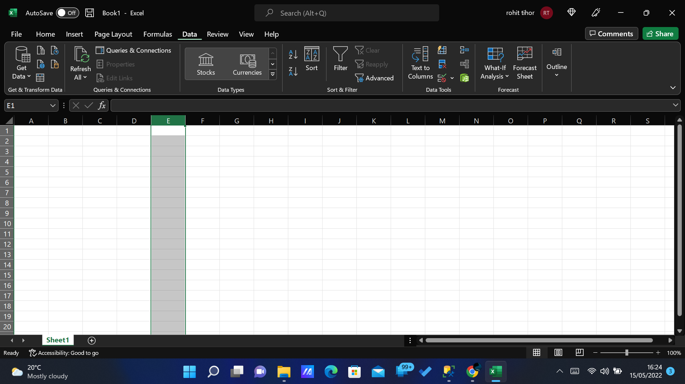Open a New Excel Notebook and choose the Get data from the toolbar and Select From database and choose From SQL Server Database. Then a pop up Box appear which ask to enter the server name.

*Fig 8.1*

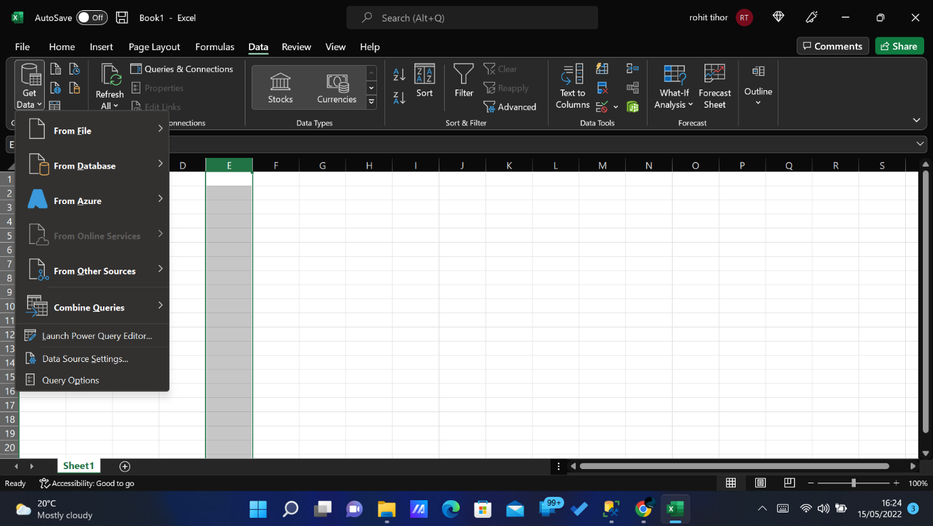

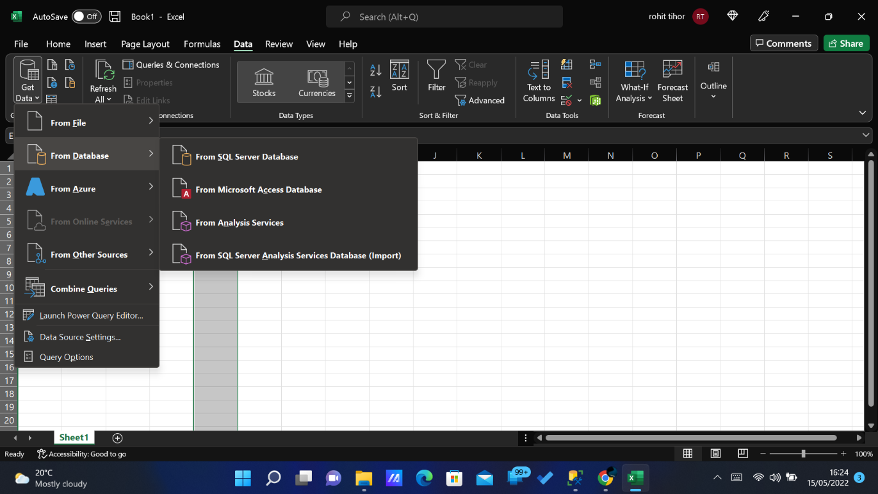 *Fig 8.2*

*Fig 8.3*

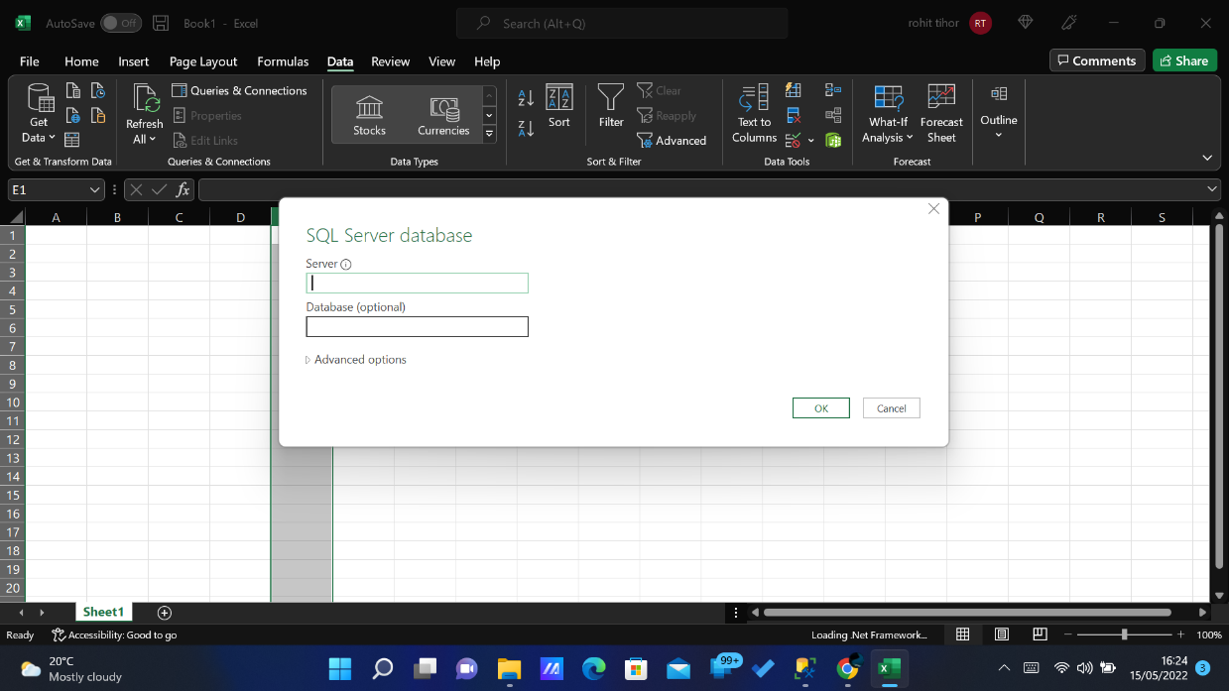  *Fig 8.4*

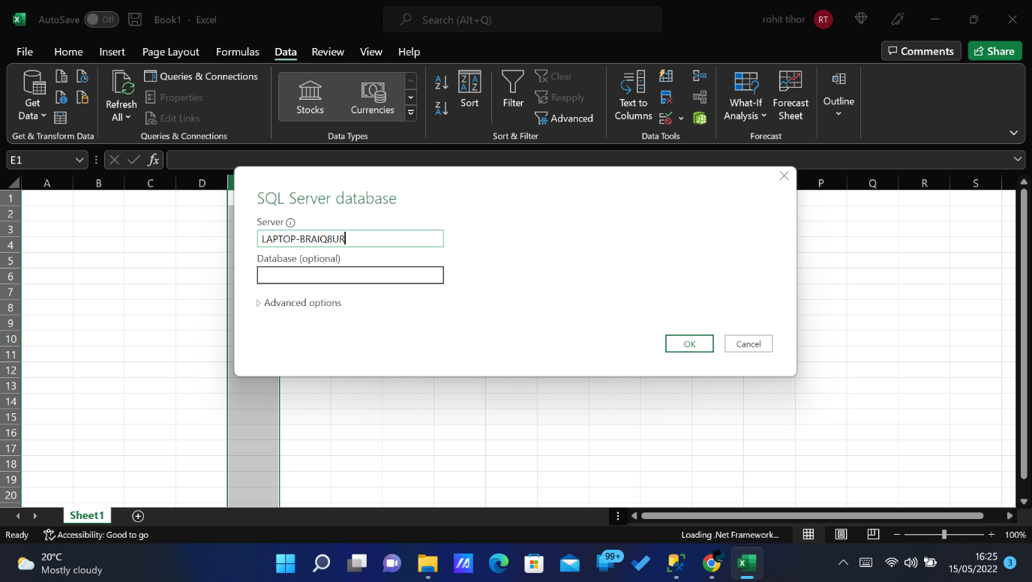

*Fig 8.5*

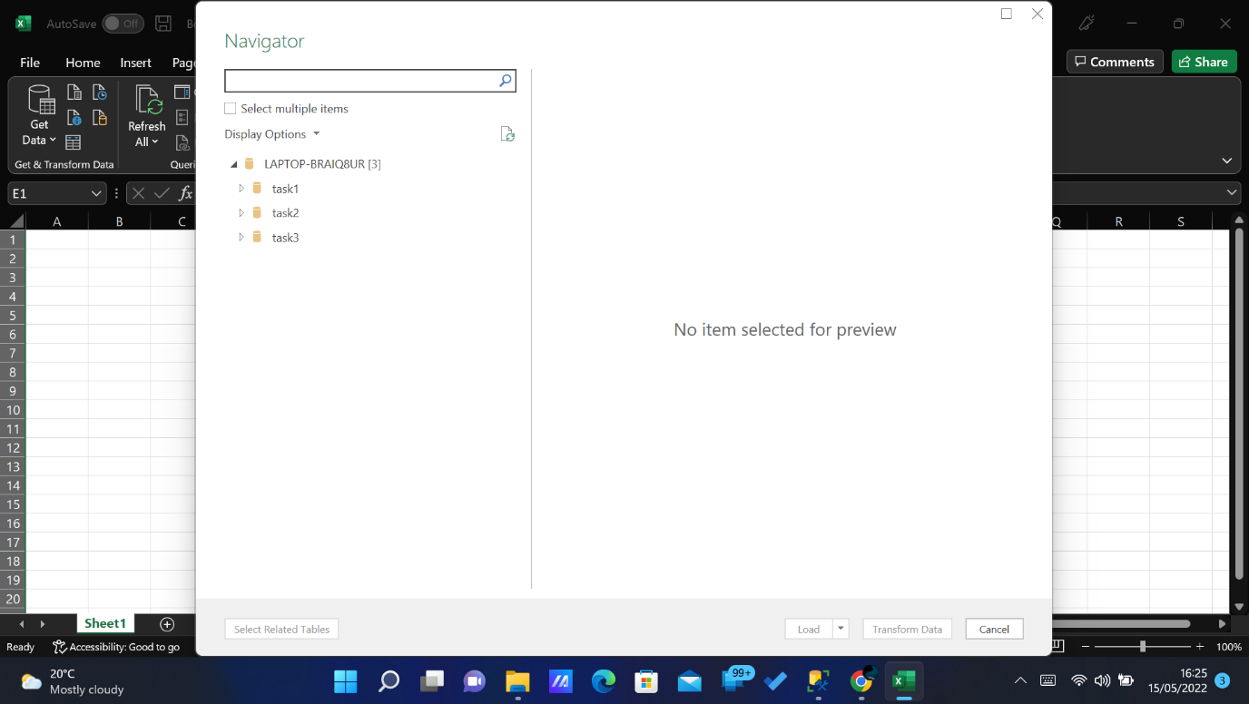

*Fig 8.6*

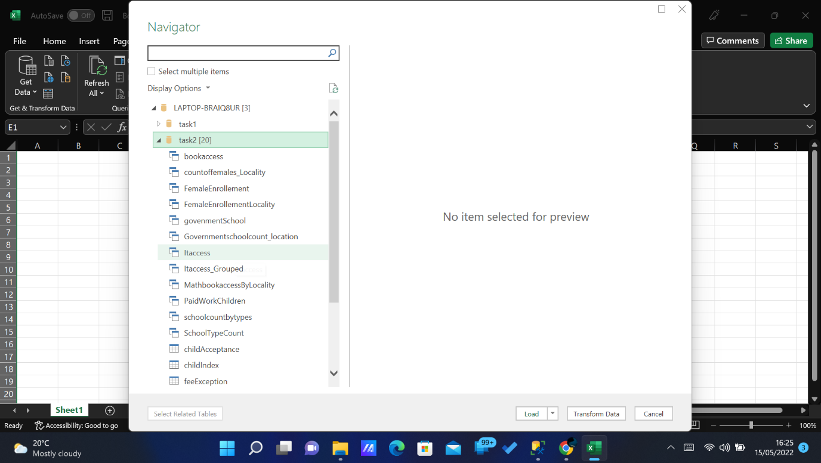

*Fig 8.7*

**Report 1:**

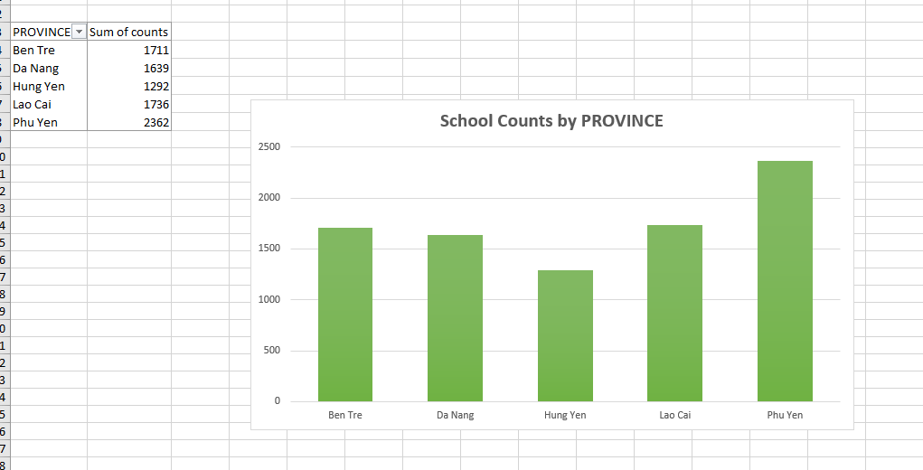

*Fig 8.8*

**Report 2:**

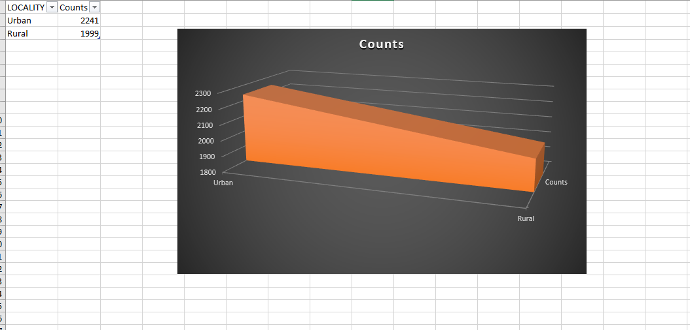

*Fig 8.9*

**Report 3:**

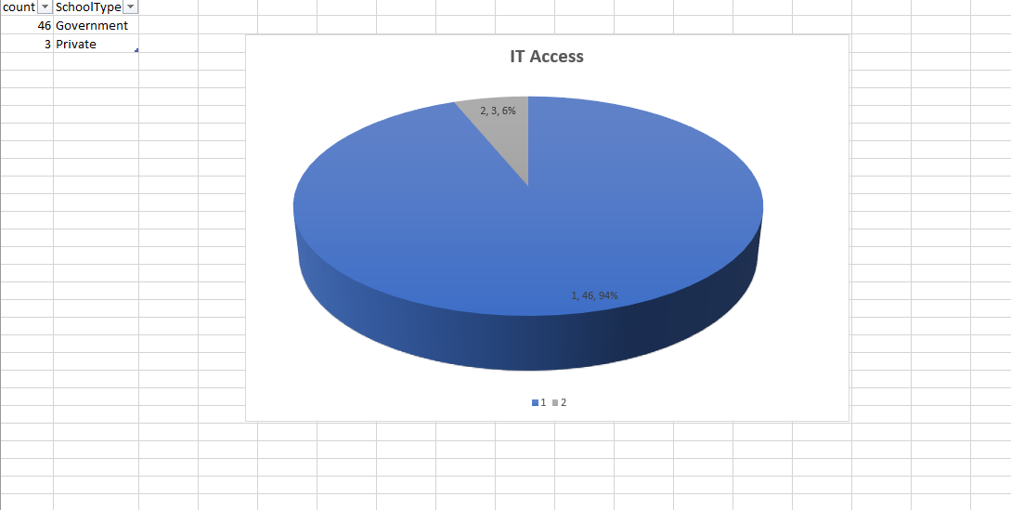

*Fig 8.10*

**Report 4:**

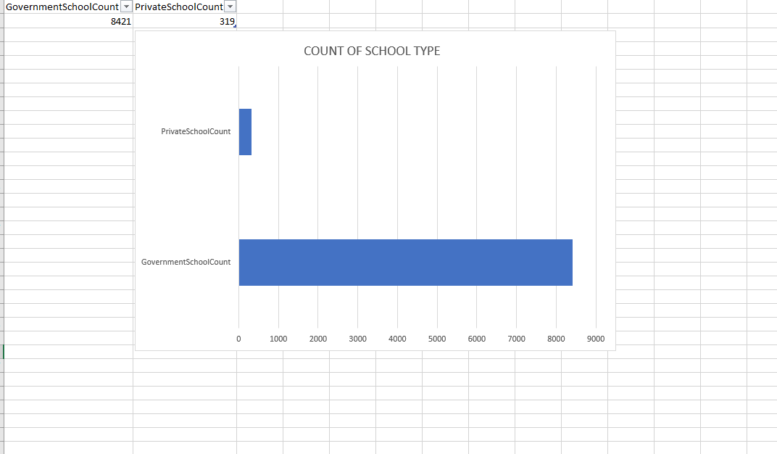

*Fig 8.11*

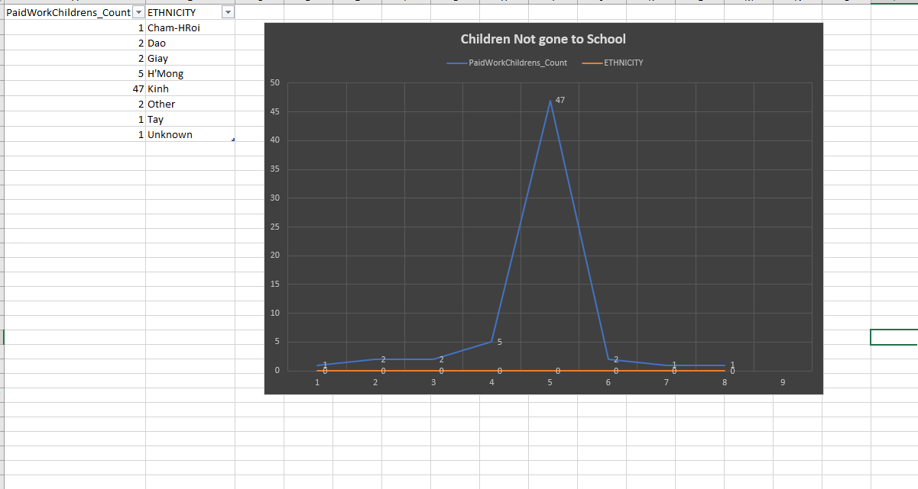**Report 5:**

*Fig 8.12*

**Report 6:**

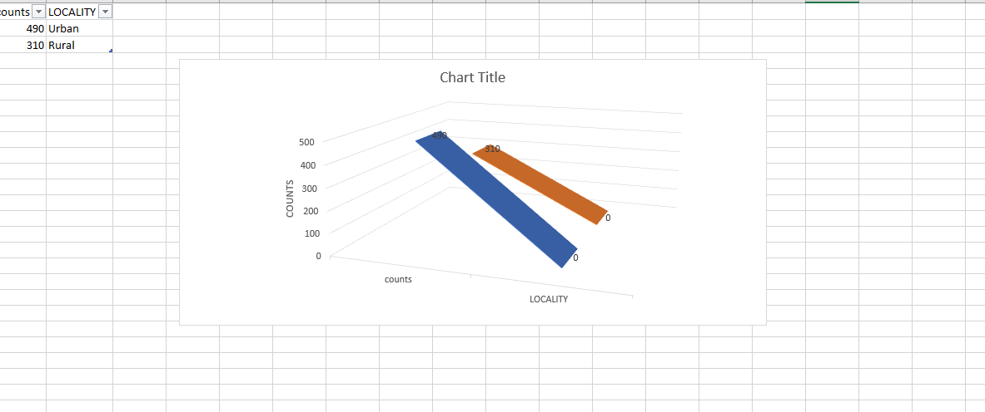

*Fig 8.13*

1. **Database Security:**

Database security refers to the various measures organizations take to ensure their databases are protected from internal and external threats. Database security includes protecting the database itself, the data it contains, its database management system, and the various applications that access it. Organizations must secure databases from deliberate attacks such as cyber security threats, as well as the misuse of data and databases from those who can access them. This was controlled with the help of Authentication and Authorization to the Db. In some case’s Views will also be authorized for only particular users.

1. **Data Privacy, Ethical and legal issues:**

Data protection is both a central issue for research ethics in Europe and a fundamental human right. It is intimately linked to autonomy and human dignity, and the principle that everyone should be valued and respected. For this principle to guide the development of today’s information society, data protection must be rigorously applied by the research community.

Depending on the setting or information in question, the failure to protect personal data against loss or misuse can have devastating consequences for the data subjects. It may also have serious legal, reputational and financial consequences for the data controller and/or processor. Many recent examples of unethical research practices have involved the unauthorised collection and/or (mis)use of personal data, resulting in enforcement action by regulators.

The principle of accountability is central to the GDPR and requires data processors to establish and document data protection compliance processes.

1. **Database Backup and Restore Strategy.**

Implemented the same technique used for the Task 1 and the database was stored safely.

1. **Data Science/Business Intelligence Techniques.**

Microsoft Excel was used for designing reports, With variety of Designs.

1. **Conclusion:**
2. The count of Government School was higher compare to the private school. When getting the count by Province only two Zones have Private School **‘Hung Yen’ , ‘Da Nang’.**
3. There are no private schools in **‘Phu Yen’.**
4. The Government Schools are lacking more in the IT Access for the students**.**
5. Urban area as more female children’s, where there is a large decline in the avilability of Math textbooks.
6. There are a lot of children’s can’t go for School because of paid work. When taking the count according to the Ethnicity “**Kinh**” has more children’s who can’t attend the school because of work.
7. Fee-Exception was made higher in the province ‘**Lao Cai’** for children’ who is from lower Ethnic Minority and remote area.

**Task 3**

1. **Abstract:**

To analysis the crimes that was happened in the Greater Manchester according to the LSOA data that was provided.

And Creating a Summarized Crime Report with the Sequences and Reporting it with the help of Microsoft Excel Sheet and using QGIS for mapping the crime reports according to the LSOA Location. The Greater Manchester Population Data was merged for creating the reports.

1. **Introduction:**

The Greater Manchester DataSet was recommended to use for the years from Jan 2017 to Dec 2018. For mapping in QGIS LSOA data was used for Plotting according to area wise using Latitude and Longitude. Vehicle Crime and Anti-Social Behaviours was reported in the Open-Street Map and Google Satellite map using the Open-Layers Plugin and the Combined Data of LSOA and Crime Data.

1. **Design Rationale:**

To join the two data’s LSOA Code was used which is common in both the datasets. This helps to Create the QGIS Mapping and write reports according to the location and Population.

1. **Tool and Programming Languages:**
2. Microsoft SQL Server Management Studio was used for configuring and Managing the Data.
3. TSQL Was used for writing Queries.
4. Microsoft Excel – For Creating Reports.
5. QGIS – Mapping the Reports.
6. **Data Source:**

The Data was Downloaded from the Link below:

**Crime’s data:**

<https://data.police.uk/data/>

**LSOA population data:**

https://www.ons.gov.uk/peoplepopulationandcommunity/populationandmigration/p opulationestimates/datasets/lowersuperoutputareamidyearpopulationestimates

1. **Database Normalisation:**

* First Normal Form (1NF) explains that Each table cell should contain a single value and Each record needs to be unique.
* Second Normal Form (2NF) has two rules:
  1. Rule 1- Be in 1NF
  2. Rule 2- Single Column Primary Key that does not functionally dependant on any subset of candidate key relation
* Second Normal Form (2NF) has two rules:

1.Rule 1- Be in 1NF

2.Rule 2- Single Column Primary Key that does not functionally dependant on any subset of candidate key relation

So with the help of the Reference that database was considered to be Normalized.

1. **Creating the Tables and inserting the Data:** 
   1. **Creating the Table CRIMES:**

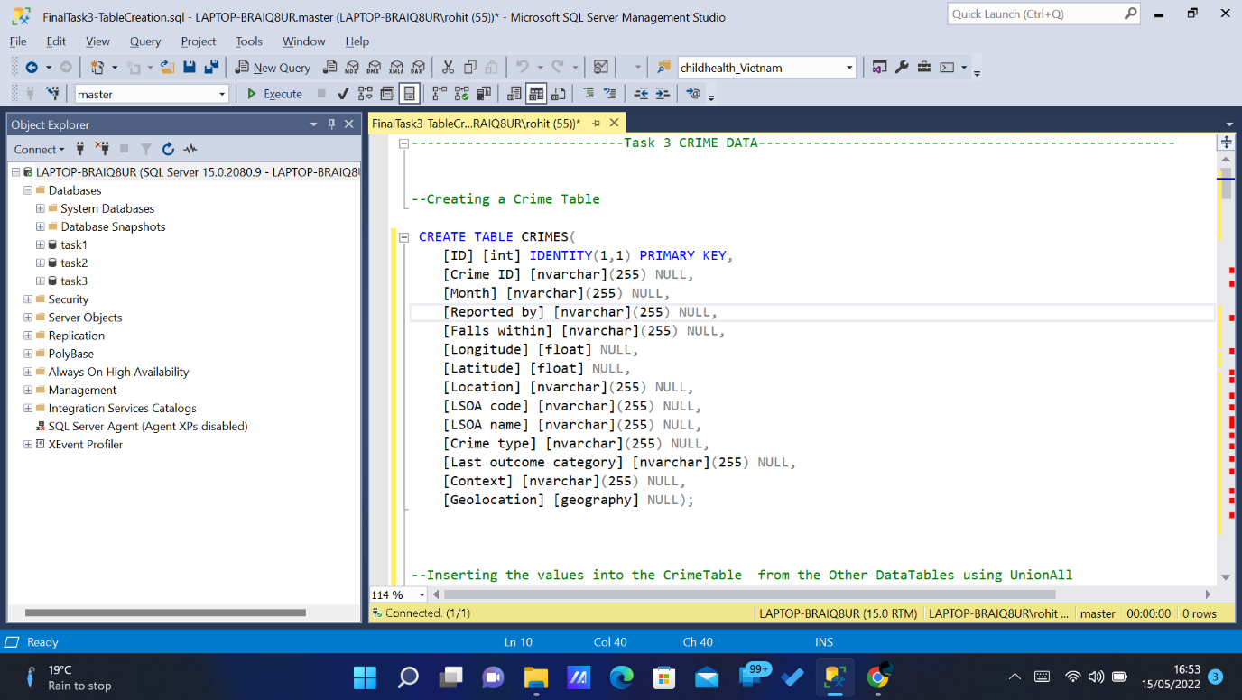

*Fig .7.1*

* 1. **. Inserting Values to the Table CRIMES:**

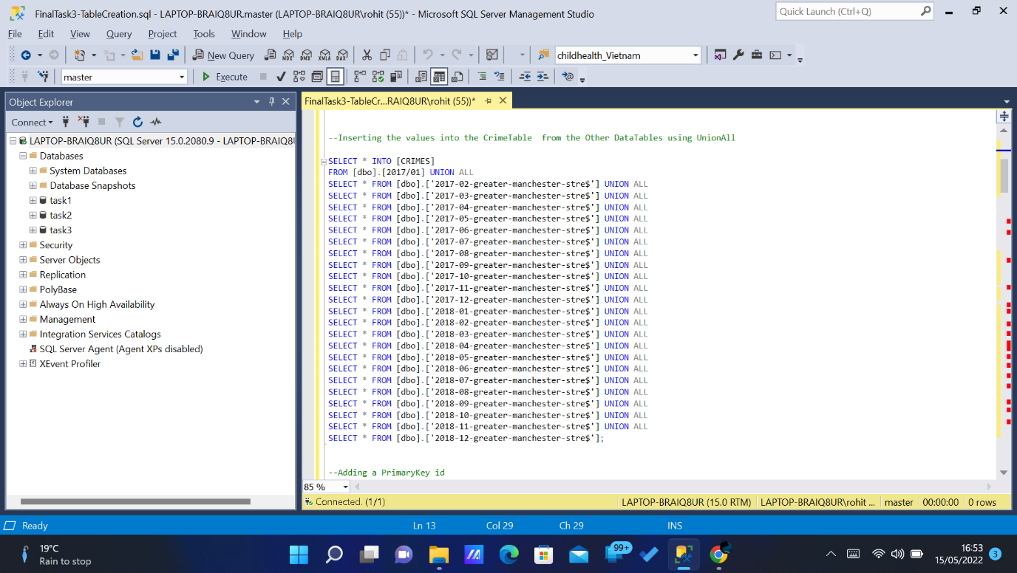

*Fig .7.2.*

* 1. **Setting primary key and ID for mapping QGIS:**

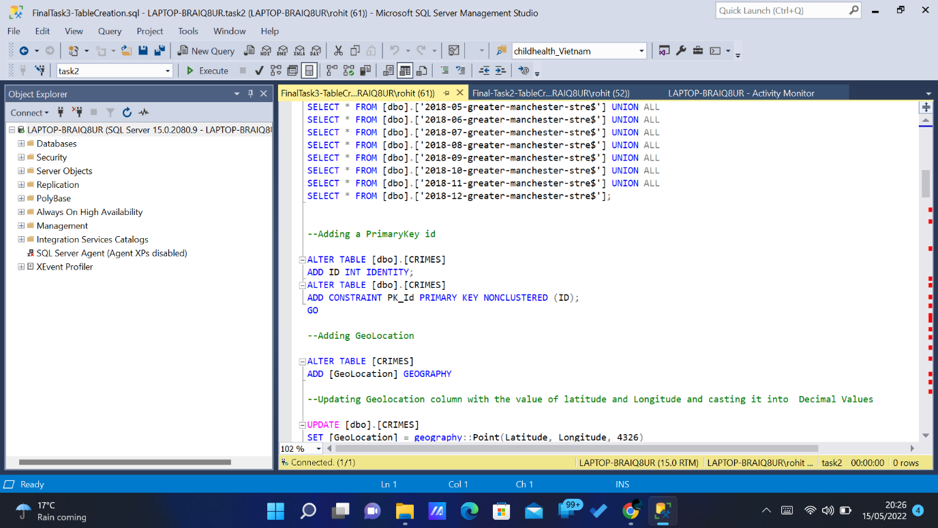

*Fig .7.3.*

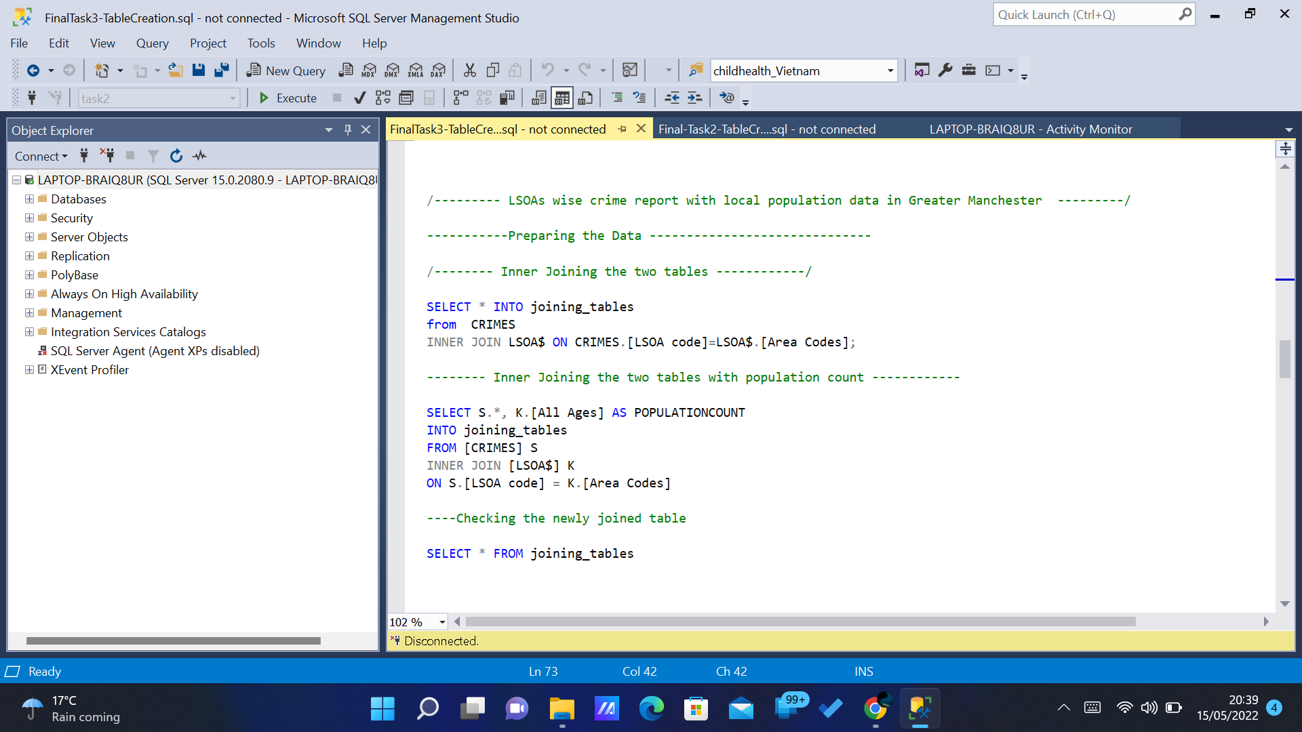

*Fig .7.4.*

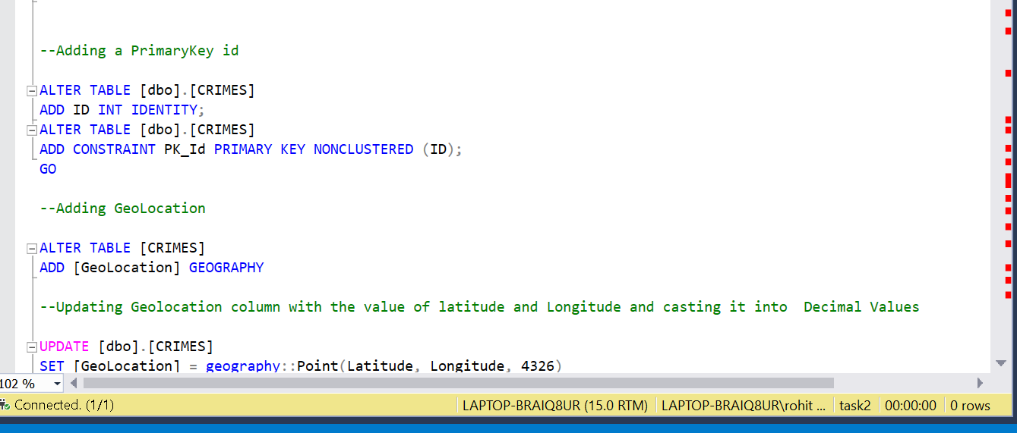 *Fig .7.5.*

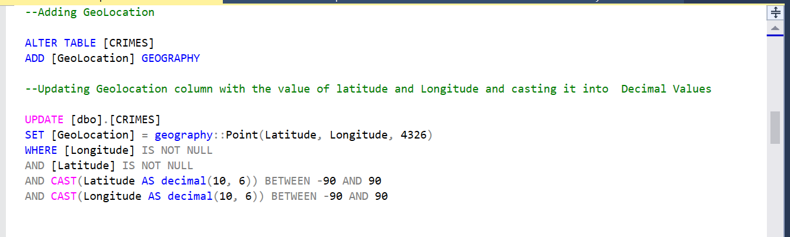

*Fig .7.6.*

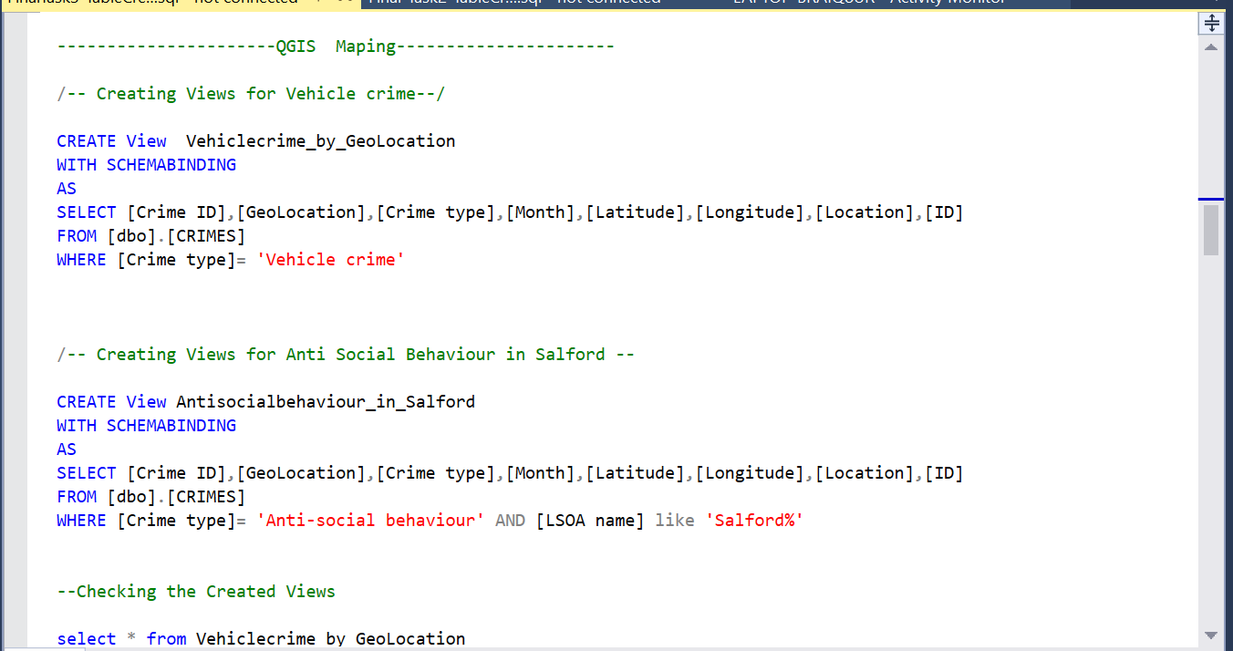 *Fig .7.7.*

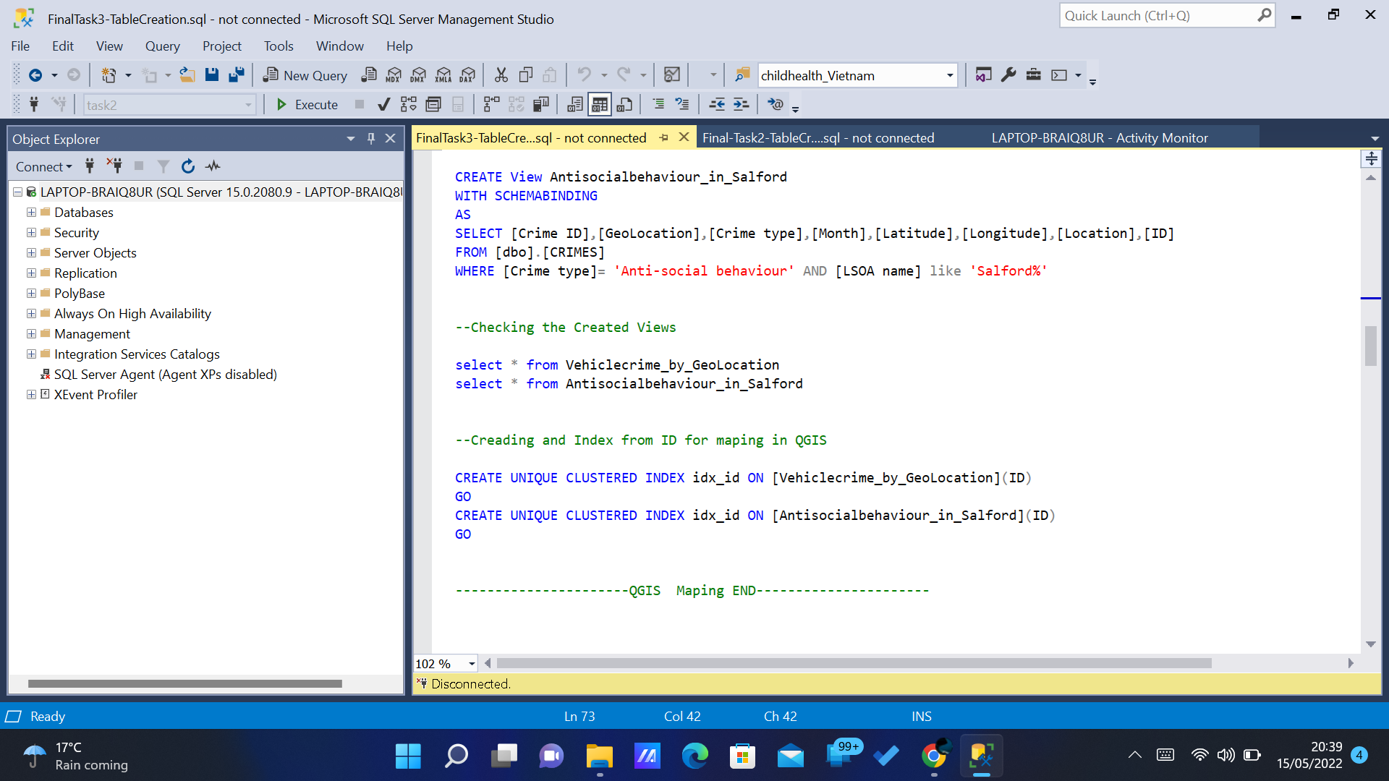

*Fig .7.8.*

1. **T-SQL Statements:**
2. **Query 1:**

Counting the Crime Types by Location and population of top 100.

CREATE OR ALTER VIEW CountofCrime_AllLocation

AS

SELECT [LSOA name],[Location],[Crime type],[POPULATIONCOUNT] as Population ,COUNT([Crime type]) AS Count_of_Crime

FROM [dbo].[joining_tables]

GROUP BY [Crime type],[LSOA name],[Location],[POPULATIONCOUNT]

Create view Count_of_Top100 as

select TOP(100)* from CountofCrime_AllLocation ORDER BY Count_of_Crime desc

select * from Count_of_Top100

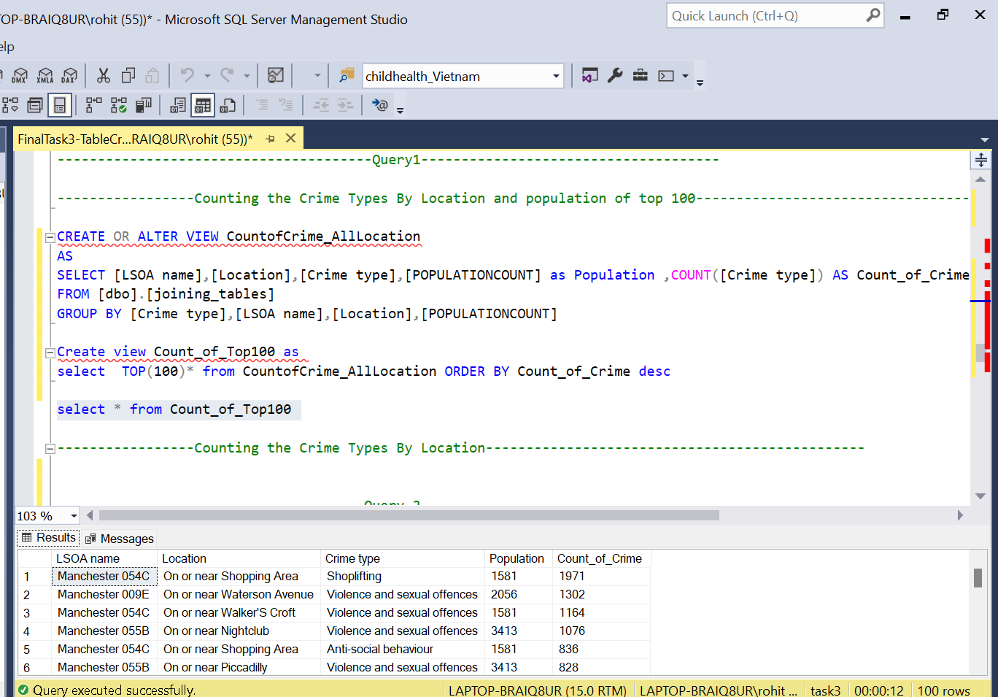

*Fig .8.1.*

1. **Query 2:**

Getting the Count of Bicycle Crime Reported in Trafford.

CREATE OR ALTER VIEW Bicycle_Crime_Trafford

AS

SELECT [LSOA name],[Crime type],[POPULATIONCOUNT] as Population ,COUNT([Crime type]) AS Counts

FROM [dbo].[joining_tables]

where [LSOA name] like 'Trafford%' AND [Crime type] = 'Bicycle theft'

GROUP BY [Crime type],[LSOA name],[POPULATIONCOUNT]

CREATE OR ALTER VIEW BicycleTheftTrafford

as select [LSOA name],Counts from Bicycle_Crime_Trafford

select * from BicycleTheftTrafford order by Counts desc

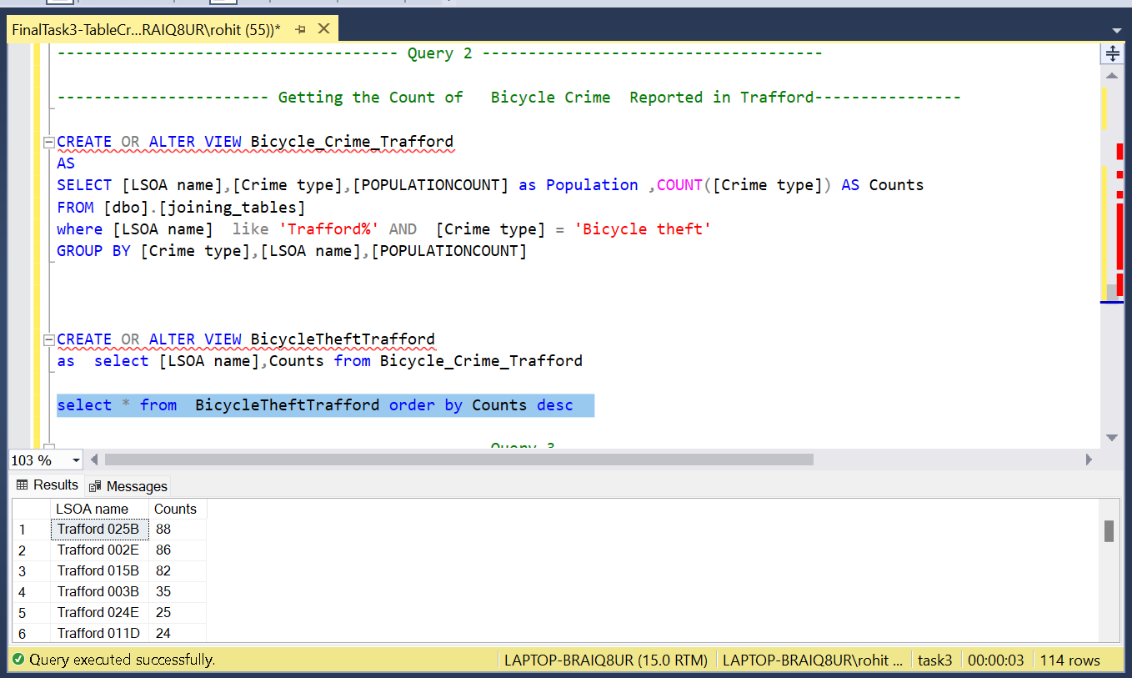 *Fig .8.2.*

1. **Query 3:**

Getting the Count of Population by LSOA Location.

Create OR ALTER VIEW PopulationCountByLSOA as

Select [POPULATIONCOUNT] as Population ,[LSOA name] as counts from joining_tables

group by [POPULATIONCOUNT],[LSOA name]

Create OR ALTER VIEW top5PopulatedLocations as

Select top(5) * from PopulationCountByLSOA

select * from top5PopulatedLocations order by counts desc

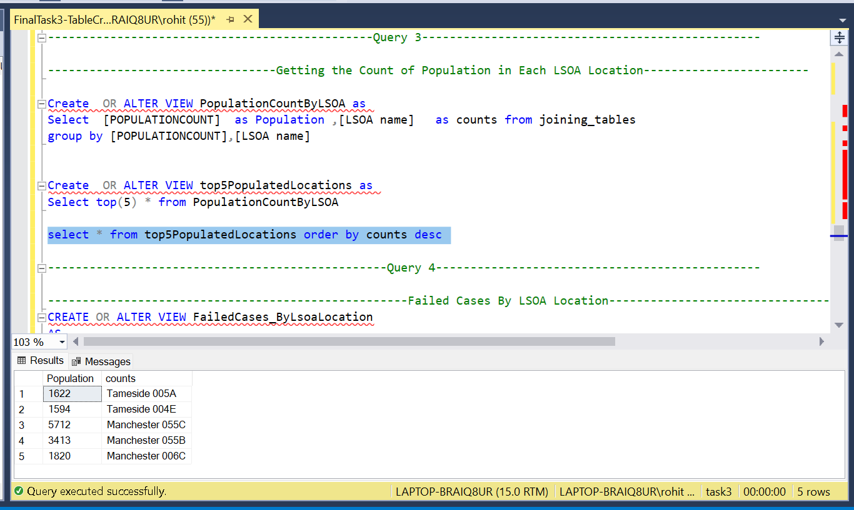

*Fig .8.3.*

1. **Query 4:**

Count of Failed Cases by LSOA Location.

CREATE OR ALTER VIEW FailedCases_ByLsoaLocation

AS

SELECT [Last outcome category],[POPULATIONCOUNT] as Population,[LSOA name],[Crime type]

FROM [dbo].[joining_tables]

where [Last outcome category] is not null AND [Last outcome category] = 'Unable to prosecute suspect'

GROUP BY [Last outcome category],[POPULATIONCOUNT],[LSOA name],[Crime type]

CREATE OR ALTER VIEW FailedCasesCountTop10

AS

Select TOP (10) * FROM FailedCases_ByLsoaLocation

select * from FailedCasesCountTop10

*Fig .8.4.*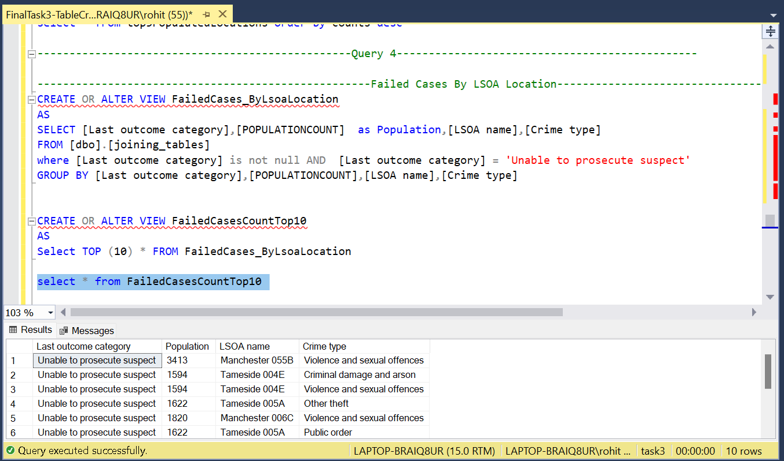

1. **Query 5:**

TOP 10 Crimes Happened in the year 2017 in Bolton.

Create OR ALTER VIEW BoltonCrimesList2017

AS

SELECT [Month],[LSOA name],[Crime type],[POPULATIONCOUNT] as Population

FROM [dbo].[joining_tables]

where [Month] like '%2017%'

AND [LSOA name] like 'Bolton%'

GROUP BY [Month],[LSOA name],[Crime type],[POPULATIONCOUNT]

Select * from BoltonCrimesList2017

Create OR ALTER VIEW BoltonTop10LSOACrimeCount

as

select Count([Crime type]) as Counts,[LSOA name] from

BoltonCrimesList2017

GROUP BY [LSOA name]

select TOP(10) * from BoltonTop10LSOACrimeCount order by Counts desc

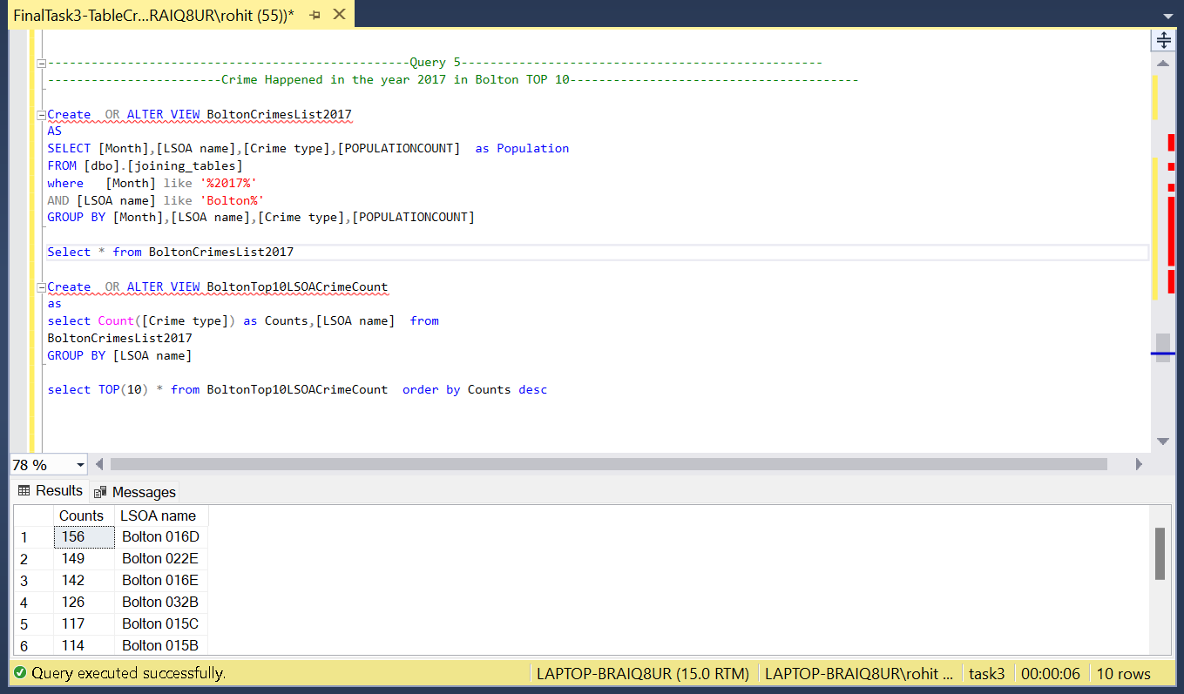

*Fig .8.5.*

1. **Query 6:**

Comparing the crime count of the year 2017 and 2018 in Bolton, Salford, Manchester.

Create OR ALTER VIEW Total_Number_of_theft_2017

AS

SELECT [Month],[LSOA name],[Crime type]

FROM [dbo].[joining_tables]

where [Month] like '%2017%' and [LSOA name] like 'Bolton%'or [LSOA name] like 'Manchester%'

or [LSOA name] like'salford%'

GROUP BY [Month],[LSOA name],[Crime type]

Create OR ALTER VIEW Total_Number_of_theft_2018

AS

SELECT [Month],[LSOA name],[Crime type]

FROM [dbo].[joining_tables]

where [Month] like '%2018%' and [LSOA name] like 'Bolton%'or [LSOA name] like 'Manchester%'

or [LSOA name] like'salford%'

GROUP BY [Month],[LSOA name],[Crime type]

Create OR ALTER VIEW ComparingTwoYears as

Select(Select count([Crime type]) as CrimeRate2017 from Total_Number_of_theft_2017)as Crime_Rate_in_2017,

(Select count([Crime type]) as CrimeRate2018 from Total_Number_of_theft_2018) as Crime_Rate_in_2018

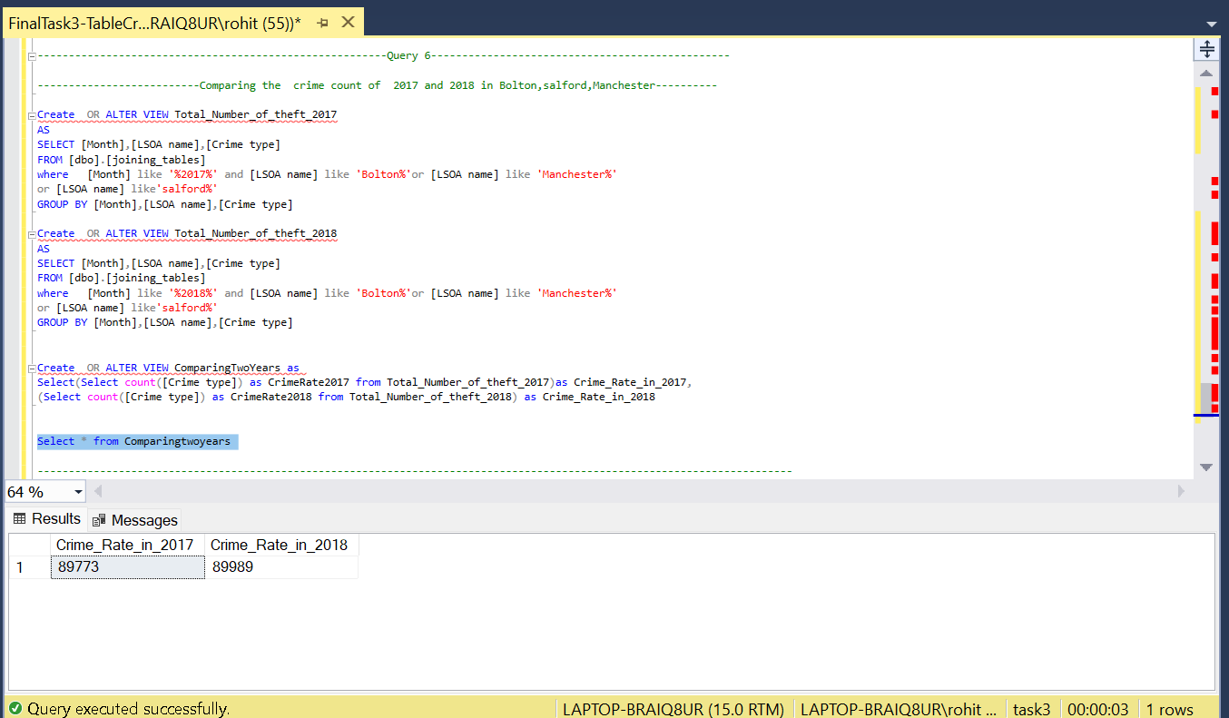Select * from Comparingtwoyears

*Fig .8.6.*

1. **Reports Designs:**

Microsoft Excel was used for the reports Creation. Earlier in Task 2 it was showed on connecting to the SQL Server Database.

1. **Report 1:**

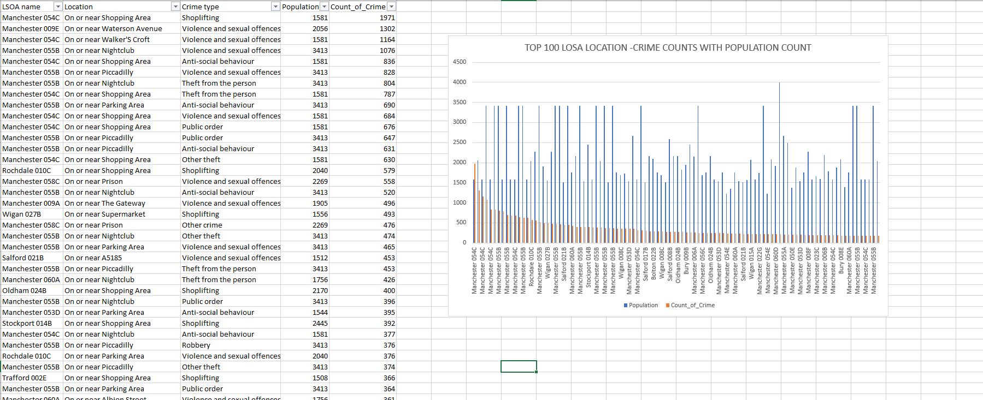

*Fig .9.1.*

1. **Report 2:**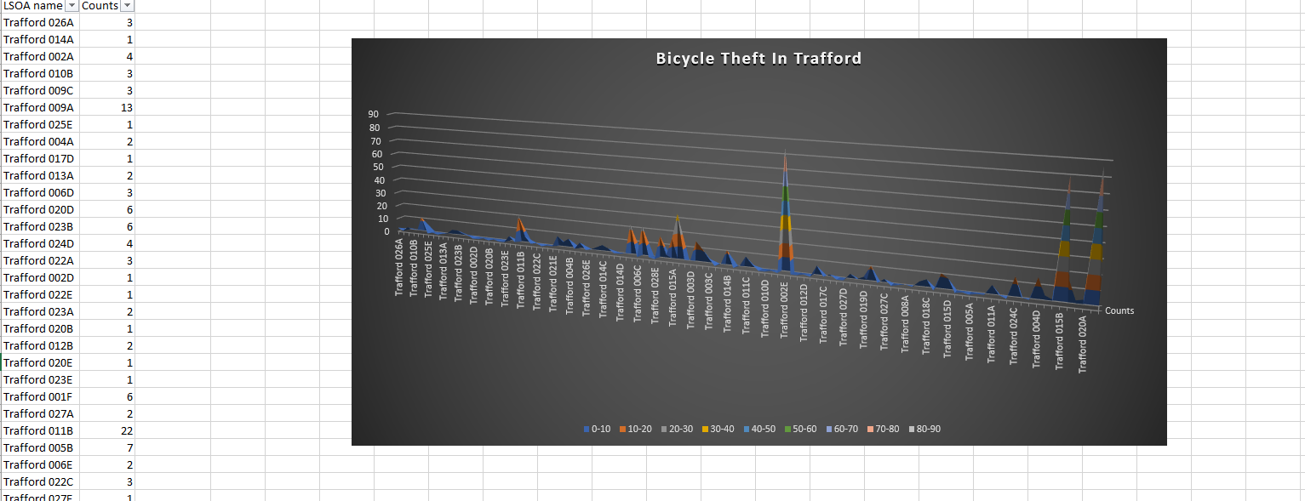

*Fig .9.2.*

1. 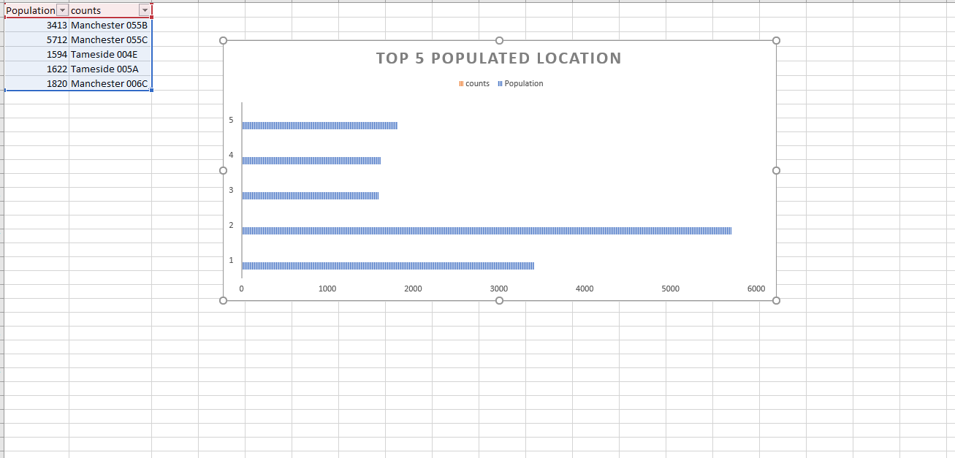**Report 3:**

*Fig .9.3.*

1. **Report 4:**

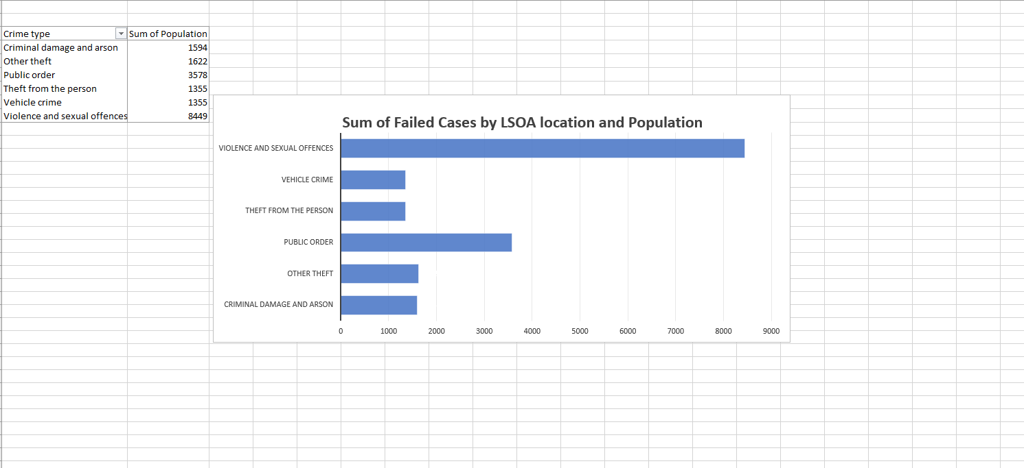

*Fig .9.4.*

1. 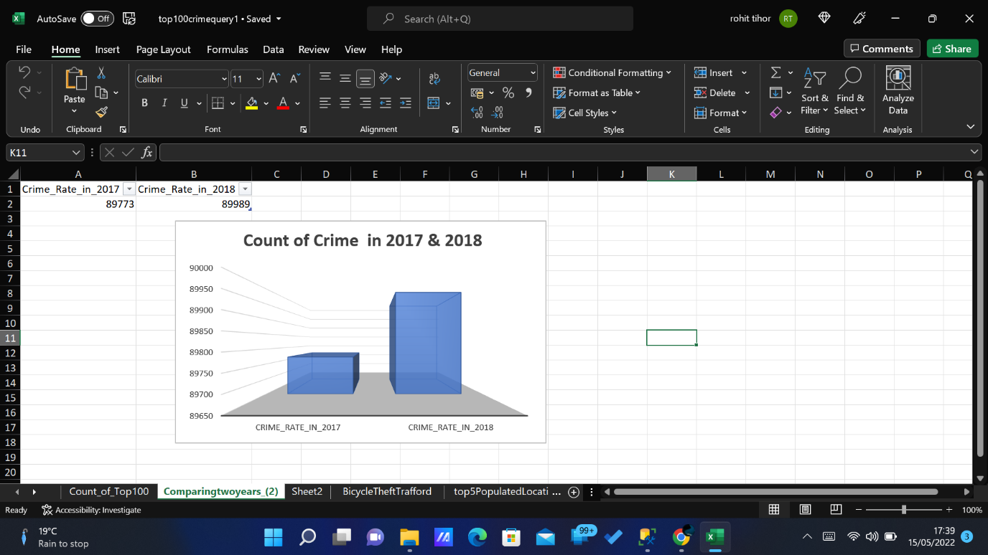**Report 6:**

*Fig .9.5.*

1. **Creating Visualization with the help of QGIS.**

Creating visualization on maps and satellite using QGIS

1. Create a new Project in QGIS.
2. Click on Connection and choose SQL Spatial Layer.
3. Create a new Connection and then choose the Desired Database.
4. Click on the Test Connection.
5. Select the View and click on Add layer.

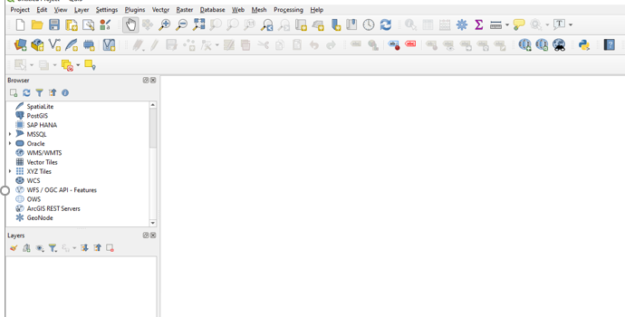

*Fig .10.1.*

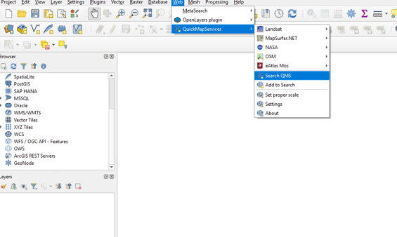

*Fig .10.2.*

1. **Anti-Social behaviour**

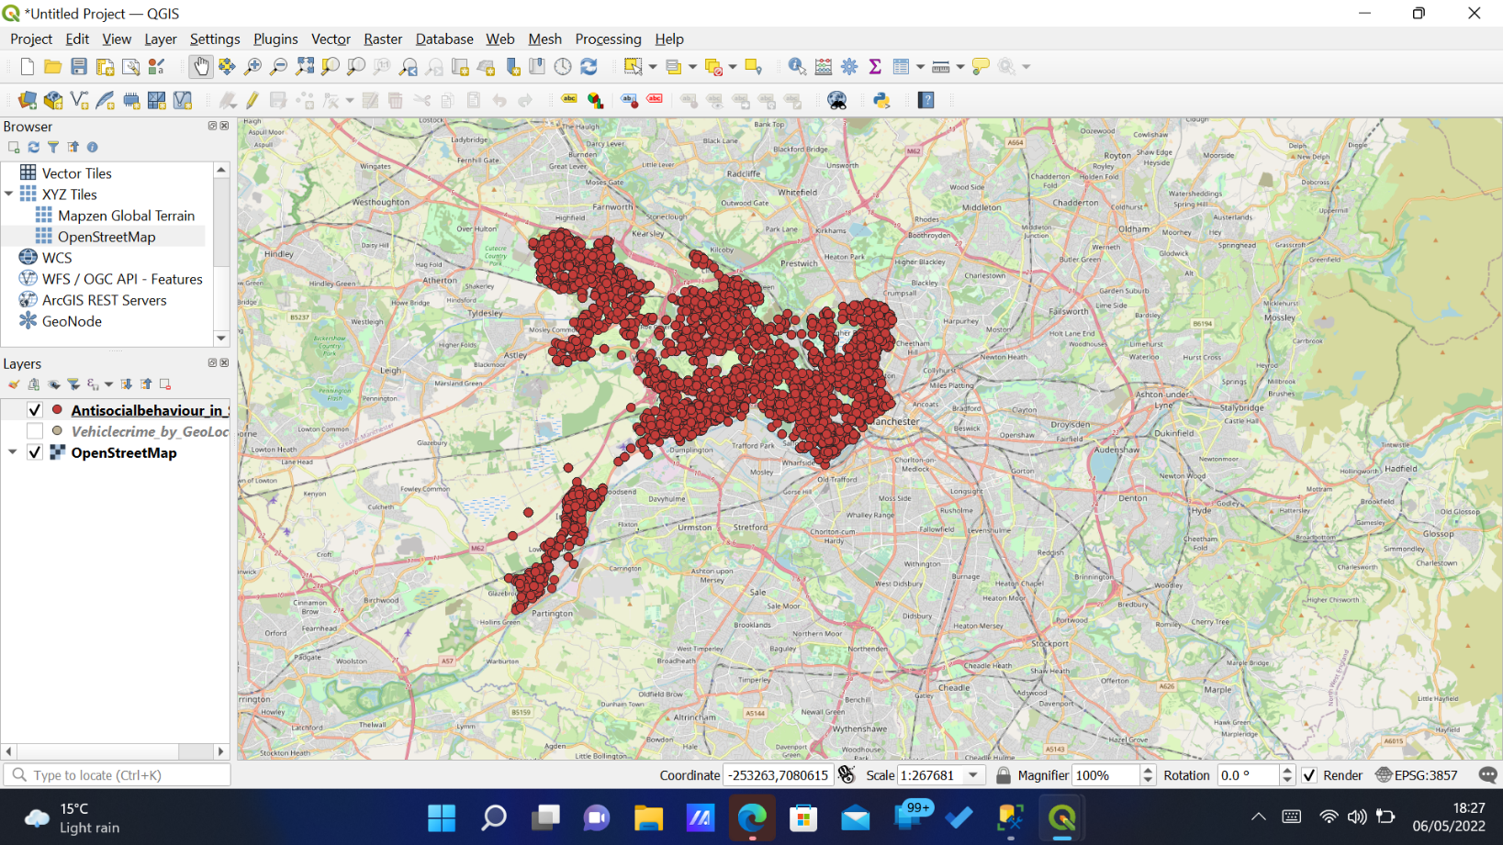

*Fig .10.3.*

1. 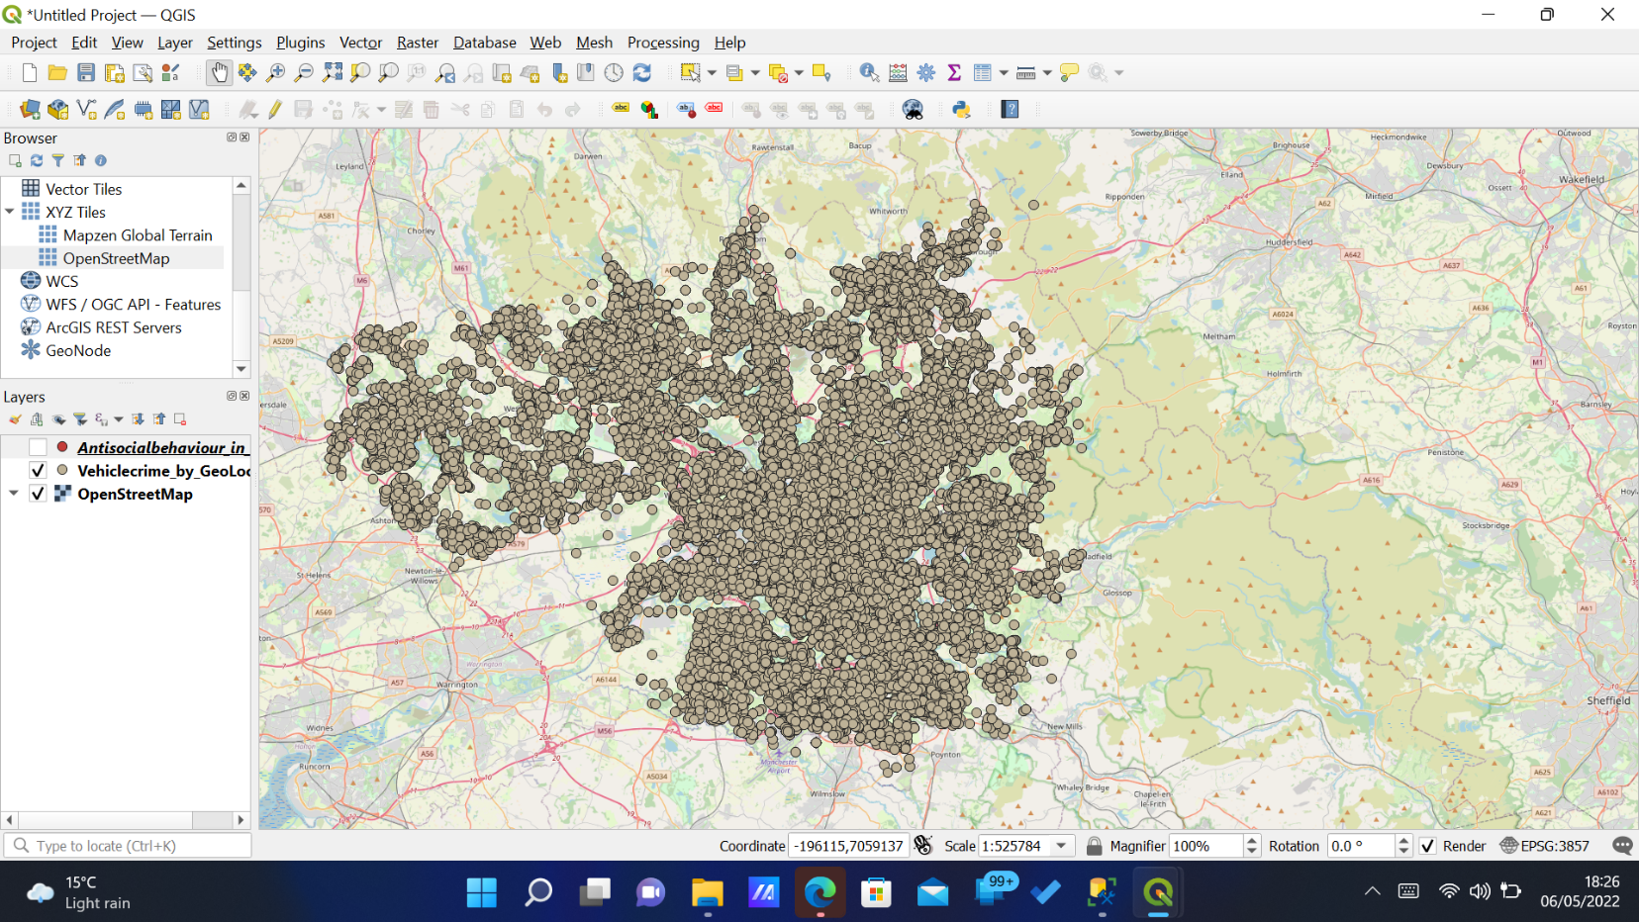**Vehicle Crime by Geo Location.**

*Fig .10.4.*

1. **Database Backup and Restore Strategy:**

The earlier ways for the task1 are used for implementing the database Backup and the data is Stored in the filesystem for safety purpose.

1. **. Data Privacy, Ethical and legal issues:**

Data protection is both a central issue for research ethics in Europe and a fundamental human right. It is intimately linked to autonomy and human dignity, and the principle that everyone should be valued and respected. For this principle to guide the development of today’s information society, data protection must be rigorously applied by the research community.

Depending on the setting or information in question, the failure to protect personal data against loss or misuse can have devastating consequences for the data subjects. It may also have serious legal, reputational and financial consequences for the data controller and/or processor. Many recent examples of unethical research practices have involved the unauthorised collection and/or (mis)use of personal data, resulting in enforcement action by regulators.

The principle of accountability is central to the GDPR and requires data processors to establish and document data protection compliance processes.

1. **Data Science/Business Intelligence Techniques.**

Microsoft Excel was used for designing reports, With variety of Designs. In Addition as the Data contains the Latitude and longitude Information’s QGIS was used for mapping the data’s for clear understanding.

1. **Conclusion:**
2. The Crime Cases were increased in the year 2018 by 4 % compare to the year 2017.
3. Bolton ‘016D’ (LSOA Name) has highest crime count rate 156.
4. Manchester 055B (LSOA Name) has the highest number of failed cases compare to the other Area’s and the type of Crime is Violence and Sexual Offence.
5. Population was higher in Tameside 005A (LSOA Name).
6. Bicycle theft was higher in Trafford 025B with a count of 88

**References:**

1. <https://ec.europa.eu/info/funding-tenders/opportunities/docs/2021-2027/horizon/guidance/ethics-and-data-protection_he_en.pdf>.
2. **https://docs.microsoft.com/en-us/sql/ssms/sql-server-management-studio-ssms?view=sql-server-ver15.**